Official
User Guide



Linux Mint 6 “Felicia”
Main Edition
Document Version 1.2

Table of Contents
Table of Contents
Table of Contents 2
Introduction to Linux Mint 3
History 3
Purpose 3
Version numbers and codenames 4
Editions 4
Where to find help 5
Installation of Linux Mint 6
Download the ISO 6
Via Torrent 7
Install a Torrent client 7
Download the Torrent file 7
Via a download mirror 7
Read the Release Notes 7
Check the MD5 8
Burn the ISO to CD 9
Boot the LiveCD 9
Install Linux Mint on your Hard-Drive 10
First Boot Configuration 24
Introduction to the Linux Mint Desktop 34
The Gnome Desktop 34
MintDesktop 34
MintMenu 37
Get to know mintMenu 37
The “Places” menu 37
The “System” menu 43
The “Applications” menu 48
The “Search” field 51
Define your favorite applications 51
Make your own shortcuts 52
Launch applications automatically when you log in 52
Change the appearance of mintMenu 52
Activate the Recent plug-in 53
Restore the default settings 54
Replace mintMenu with the default Gnome menu 54
Change other settings 55
Install/Remove Applications 57
Package Management in Linux Mint 57
Install new applications 58
MintInstall, the Software Manager 58
Synaptic & APT 59
Remove applications 60
APT 61
Synaptic 62
Update your system and your applications 62
Using mintUpdate 63
Make the most of your desktop 69
Copy and paste with the mouse 69
Takes notes with Tomboy 70
Share files with mintUpload 72
Use a Mint-Space account with mintUpload 74
Use an FTP account with mintUpload 76
Archive emails and websites as PDF 77
Conclusion 77

Introduction to Linux Mint
Linux Mint is an operating system designed to work on PC and on x86 computers.

The same way a computer can run Microsoft Windows it can run Linux Mint instead, or even run both. A computer running both Windows and Linux is known to “dual-boot” (the user selects which operating system is to be launched when the computer is turned on). This is also true with Apple Mac OS, with BSD, with other flavors of Linux and in a general way with any other operating system. A computer can even “multi-boot” and offer a wide selection of operating systems at boot time.

Linux Mint works well on its own without the need for any other operating systems but it also cohabitates well, auto-detects and communicates well with other operating systems. For instance, if you install Linux Mint on a computer currently running Microsoft Windows (XP, Vista or any version), Linux Mint will detect Windows, a dual-boot will automatically be set up for you to choose between Linux Mint and Windows at boot time and you will even be able to access your Windows files from Linux Mint.

As Linux is more secure, more stable, more efficient and nowadays easier to use than Windows, it represents a great alternative for individuals and for companies.

History
Linux Mint is a very modern operating system. Its development only started in 2006. Yet, it is based on very mature software layers and takes advantage of the Linux kernel, the GNU tools and the Gnome desktop. It also relies on the Ubuntu and Debian projects and uses their system as a base.
The Linux Mint project focuses on making the desktop more usable and more efficient for every day tasks for the user. Underneath the desktop the operating system benefits from a very strong base, a huge collection of available software and a very well integrated set of services.
From the beginning of the project Linux Mint quickly became popular and is now among the most used PC operating system in the World.

Purpose
The purpose of Linux Mint is to provide a desktop operating system that home users and companies can use at no cost and which is as efficient, easy to use and elegant as possible.
One of the ambitions of the Linux Mint project is to become the number 1 alternative to Microsoft Windows on the PC by making it easy for people to get to use advanced technologies rather than by simplifying them or making them look similar to what already exists in Windows.
The goal is not to look like Microsoft Windows or Apple Mac OS, but to develop our own idea of the ideal desktop. We should make the best out of the most modern and cutting-edge technologies that exist under Linux and make it easy for everybody to use the most advanced features.

Version numbers and codenames
This guide covers version 6 of Linux Mint which codename is “Felicia”.
Version numbers and codenames follow a unique logic in Linux Mint:
- Since version 5, Linux Mint follows a 6 months release cycle and uses a simplified version scheme. The version number simply gets incremented every 6 months.
- If revisions are made to a particular release (a bit like Service Packs in Windows) its version number gets a minor revision increment. For instance “6” would become “6.1”.
- Codenames in Linux Mint are always female names ending with “a”. They follow the alphabetical order and the first letter of the codename corresponds to the index of the version number in the alphabet.

So far Linux Mint used the following codenames:
Version | Codename
1.0 | Ada
2.0 | Barbara
2.1 | Bea
2.2 | Bianca
3.0 | Cassandra
3.1 | Celena
4.0 | Daryna
5 | Elyssa
6 | Felicia

Editions
This guide covers the Main Edition.
An Edition is a release of Linux Mint which is customized to address a certain need. Here are the most popular editions:
- Main Edition
- Universal Edition (based on the Main Edition, it comes without multimedia codecs and patented technologies, with a text-based Grub boot menu for improved compatibility and with support for all major languages)
- x64 Edition (same as the Main Edition but optimized for 64bit architectures)
- KDE Community Edition (uses a KDE desktop)
- XFCE Community Edition (uses an XFCE desktop)
- Fluxbox Community Edition (extremely lightweight for older computers)
As you can see, some of these editions are labeled “Community Edition”. This means they are developed and maintained by the Linux Mint Community. If you don’t know which edition to use, you should choose the Main Edition.
If you intend to redistribute or to make commercial use of Linux Mint in the USA or in Japan and if you’re not sure about patent legislation you should use the Universal Edition.
If you have less than 4GB of RAM, even if your processor is 64bit, you should choose the Main Edition. There is no tangible performance gain on computers with less than 4GB of RAM between the Main and the x64 Edition and the Main Edition is known to be more stable (X86_64 is quite new and most software actually runs faster and better in a 32bit environment, no matter whether the CPU actually supports 64bit or not).

Where to find help
Linux Mint users are usually very helpful and very active. If you have questions or a problem related to Linux Mint you should be able to meet other users online and get help from them.
First, make sure to register with the “Linux Mint Forums”. This is the very first place where you can find help: http://www.linuxmint.com/forum
If you want to chat with other users you can connect to the IRC chat room. Under Linux Mint simply launch “XChat-Gnome” from the menu. If you’re using another operating system or another IRC client make sure to connect to the irc.spotchat.org server and to join the #linuxmint channel.
Linux Mint is using Ubuntu repositories and is fully compatible with it so 99% of all resources, articles, tutorials and even software made for Ubuntu 8.10 “Intrepid Ibex” also work for Linux Mint 6 “Felicia”. If you can’t find help on a specific subject for Felicia, make sure to search on the same subject for Intrepid.

Note: Ubuntu is another operating system based on GNU/Linux.

Note: A repository is like an online service in which software is stored and made available for the operating system to install and update from. Most operating systems based on GNU/Linux use repositories and connect to them via HTTP or FTP to install and upgrade not only themselves but all the software applications that are compatible with them.
Finally, if you can’t find any help at all or if you would like to be sure you always get 1st class attention from the developers you can buy professional support at this address: http://linuxmint.com/support.php

Installation of Linux Mint
You can download the Linux Mint operating system for free. It usually comes as a 700MB ISO file which you need to burn to a CD. The CD is then bootable and provides a live operating system which you can try without affecting your PC.
If you like what you see from the liveCD, you can decide to install the system to your hard-drive. All necessary tools (partitioning and installation tools) are present on the CD.

Download the ISO
Note: If you don't have broadband or if your Internet Access is too slow and 700MB is too big for you to download you can order the CD from here: http://www.on-disk.com
Visit the Linux Mint download page here: http://www.linuxmint.com/download.php
Then choose the edition you're interested in.
From this page, you should be able to find:
- an MD5 signature
- a torrent link
- a list of download mirrors
The file you need to download is an ISO file. There are two ways to download this file, by torrent (a Peer to Peer protocol) or via a download mirror (HTTP or FTP protocol). Once your download is finished, you can ensure your ISO file isn’t corrupted by checking its signature with the MD5.

Via Torrent
Torrent is a Peer to Peer (P2P) protocol. Basically, instead of downloading from a central location, a torrent lets you download part of the ISO file from different people across the Internet.
The more people download the ISO file the faster the download speed gets. This is the preferred and recommended way to download Linux Mint.

Install a Torrent client
First you need some software to be able to use the torrent.

If you run Linux you can install “Transmission”. If you run Linux Mint, Transmission is already installed.

If you run Windows you can run Azureus ( http://azureus.sourceforge.net/ ).

Download the Torrent file
The next step is to follow the torrent link from the Linux Mint website and to download the .torrent file. This file is very small and you should open it with your torrent client application.

The torrent client application will probably ask you where you want to download the ISO, select a destination and then wait for the download to complete.

More information about the torrent protocol: http://en.wikipedia.org/wiki/BitTorrent

Via a download mirror
If you can’t use the torrent protocol or if you just can’t be bothered (it happens, especially on Monday mornings) then look at the list of download mirrors and pick one of them. They’ll provide a link to the ISO file itself which you can just click to start the download.

Note: Remember that bandwidth is limited though and the more people download from a mirror, the slower the download speed gets for everybody who is downloading from that mirror.

Read the Release Notes
Your download is probably going to last at least an hour, so now would be the perfect time for you to get familiar with the new features coming with the release you’re currently downloading.
Release Notes are basically a web page which highlights the following information:
- What are the new features delivered in this release?
- What are the known problems of this release?
- How to upgrade from the previous release?
They also contain screenshots and are usually nice and easy to read. Of course, you could find out about things by yourself just by using the system but you might miss a few things and it would be a pity not to know about a new feature just because you didn’t read the release notes.
The release notes for Linux Mint 6 Felicia are available here: http://www.linuxmint.com/rel_felicia.php

Check the MD5
You’ve read the Release Notes, you just can’t wait to play with the new features and your download just finished successfully. You’re ready to burn a CD and to boot on it… but hey! Wait for a second!
If that CD is faulty you will experience weird bugs and nobody may be able to help you. The main two reasons for a CD to be faulty are:
- Something happened during the download and your ISO file isn’t exactly like the original.
- Something happened during the burning process and your CD isn’t exactly like it should be.
The MD5 signature, which is present on the download page, is a quick way for you to make sure that your ISO file is exactly like it should be. So let’s check that ISO file before we burn it and save a lot of potential and nerve-wracking problems.
If you run any version of Linux you probably already have md5sum installed. Open a terminal where your ISO file is (for instance, if “LinuxMint-6.iso” is on the Desktop), open a terminal and type:
cd
cd Desktop
md5sum LinuxMint-6.iso
This command should output a series of weird characters which represent the MD5 signature of your ISO file. This signature is an exact representation of your file (that is, any file that would be remotely different would have a different signature).
Compare that signature with the one on the download page of the Linux Mint website. If the two signatures are the same, then you know your ISO file is exactly the same as the original and you can now get ready to burn it on CD.
If you happen to run Windows, chances are you don’t have md5sum installed. You can get it from here: http://www.etree.org/md5com.html
Place the ISO file and the md5sum.exe in the same place (let’s say in C:\) and run “cmd.exe”. In the command line environment, type the following commands:
C:
cd \
md5sum LinuxMint-6.iso
Then compare the signature to the one present on the website.

Burn the ISO to CD
So you now have an ISO file which you checked with MD5. You are ready to burn it to a CD.

Note: Some editions might require a DVD. Basically, if the ISO is larger than 700MB you need a DVD (preferably a DVD-R).

Get a blank CD-R (CD-RW should work as well but are known to have compatibility issues) and your favorite marker and label the CD. This might sound stupid but it happens all the time, you can’t remember where you put that marker and before you know it you’ve got 20 unlabeled CDs sitting on your desk… so make sure to label your CD-R.

Insert the blank CD-R in the drive and get ready to burn the ISO.

If you’re running Linux with Gnome right-click on the ISO file and select “Write to Disc”.

If you’re running Linux with KDE, launch K3B and in the “Tools” menu choose “Write ISO Image”.

If you’re running Windows you can use something like ISO Recorder or InfraRecorder:
http://isorecorder.alexfeinman.com/isorecorder.htm
http://infrarecorder.sourceforge.net/?page_id=5

Note: Make sure to burn the ISO image to disk, not on the disk. A very common mistake, especially for people using Nero, is to actually burn the ISO file on the disk.. as a data file. The ISO file is an image of a disk so it needs to be burnt not as a file which will appear on the disk, but as an ISO image which will be decompressed and which content will be burnt onto the disc. After burning the CD you shouldn't see the ISO file within the disc... you should see folders like “casper” or “isolinux”... So make sure to burn the image to disc and not the file on a data disc. Most burning software have a special option for that, don't just go an move the iso file itself onto a brand new CD.

Boot the LiveCD

Place the CD in the drive and restart the computer. You should now see the following screen:
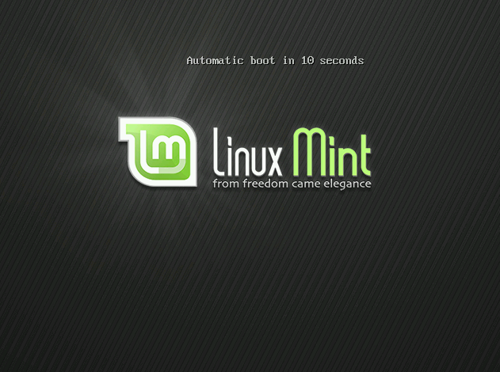
Note: If you don’t see this screen and your PC boots as usual it’s probably because your BIOS is not set to boot on CD. Restart the computer and press F1, F2 or Escape (or whatever key lets you in the BIOS configuration) so that you can change your BIOS settings and tell your computer to boot on the CD.

Install Linux Mint on your Hard-Drive
From the first screen choose the default “Start Linux Mint” option and press Enter. The liveCD should then start and you should see a screen with a progress bar:
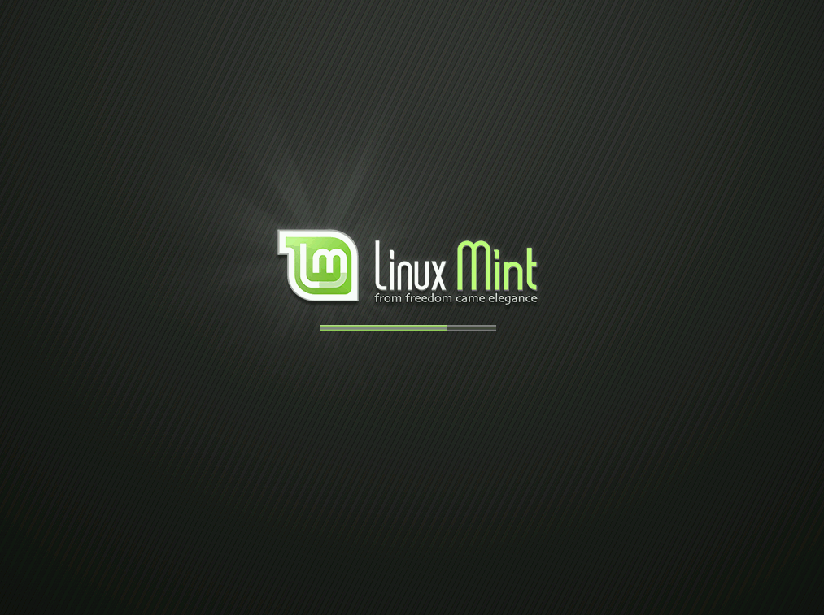
Note: If you experience problems and Linux Mint cannot manage to start try the “Start Linux Mint in compatibility mode” option from the boot menu.

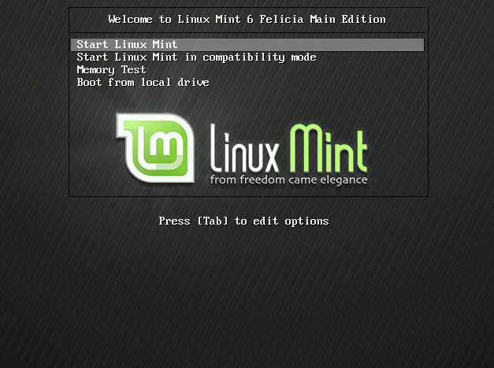
After a little while the live system should be ready and you should see the desktop:

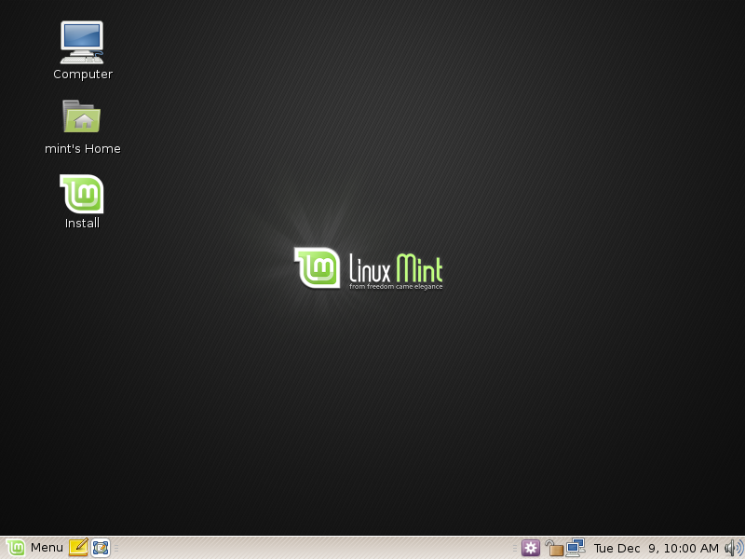
At this stage Linux Mint is not installed on your computer, it’s simply running from the CD. The system you have in front of you is almost exactly the same as the one you will have in your computer after the installation is finished.

Have fun with it and see if you like it. Bear in mind that it’s extremely slow because it runs from the CD. Once installed on the hard-drive Linux Mint is much faster.

When ready double-click on the “Install” icon located on the desktop. The Installer appears:
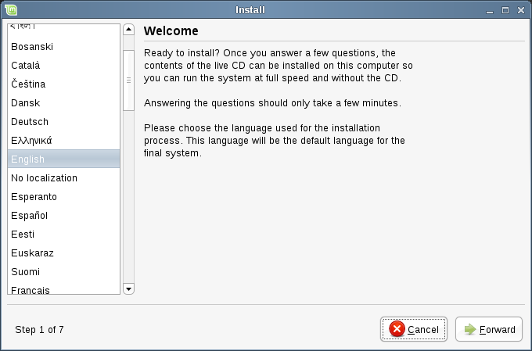
The previous chapters of this guide clearly insisted on the fact that you should read the release notes. If you haven’t read them yet then now is the time and you should click on the “Release Notes” link within the installer. Of course if your intention is not to read them at all no matter what we say and how many times we stress that you should read them… then there’s not much we can do. I guess it’s up to you after all. But hey, do read them OK? No, really. You need to read them.

So anyway, select your language and press the “Forward” button.
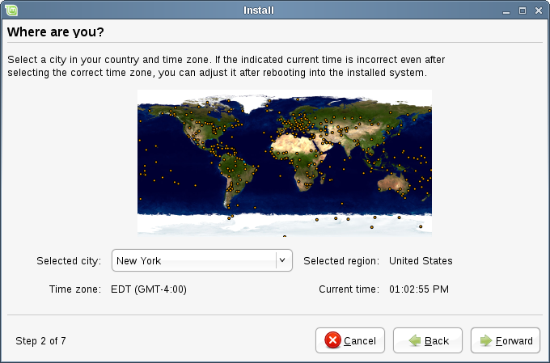
Then choose your location on the map by clicking on the city which is the nearest to you. The purpose of this step is to identify your time zone. Make sure the “Current time” appears as correct and click the “Forward” button.

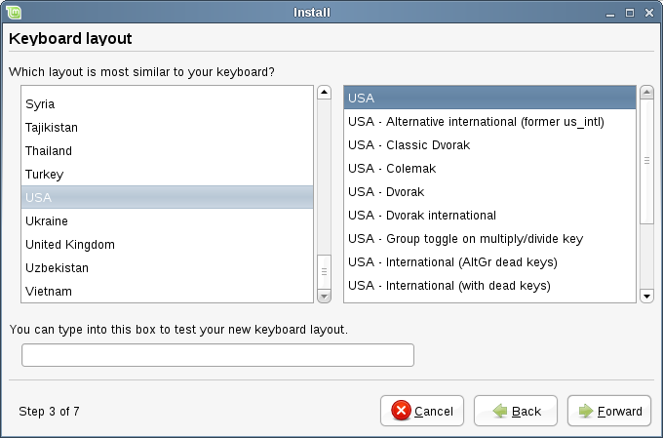
Note: Sometimes the installer is mistaken and doesn’t necessarily know about Summer/Winter time adjustments so even by selecting the proper city you might see a difference of an hour or so with the correct time. Simply ignore this at this stage and remember to make sure that the time is correct after you reboot in your newly installed Linux Mint desktop.

Select your keyboard layout. If you are not sure about which exact keyboard layout matches the keyboard you have, click on the text field at the bottom of the screen and start typing on your keyboard. Make sure the keys you press match the characters that appear in the text field in order to insure you have selected the right keyboard layout. Some layouts only differ when it comes to accents, numbers and punctuation signs so make sure to test these as well.

When you’re ready click the “Forward” button.

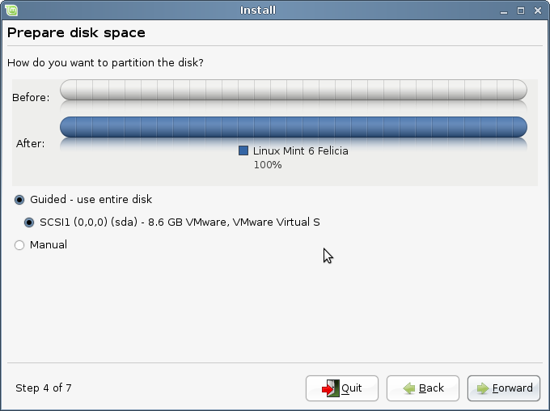
The installer is now asking you where to install Linux Mint, on which hard drive, in which partition...

If you want to allocate the full hard drive to Linux Mint, simply select the “Guided – use entire disk” option. Linux Mint will erase all data currently present on the hard drive you selected and install a brand new operating system on it.

You can also choose the option called “Guided – use the largest continuous free space”, in which case Linux Mint will allocate its partition where free space is found on the hard drive.

If you are running Windows on your computer and you want to dual boot Windows with Linux Mint, the easiest solution is to choose the “Guided – Resize” option. This will ask you how much space you want to give to Linux Mint (3GB is a minimum, 10GB is recommended, if you can give it more then even better) and it will consequently resize your Windows partition. This operation is safe and your data won't be lost. However, it's always a good idea to make a backup prior to doing this kinds of things.

The last option is called “Manual” and it lets you create, remove, and organize the partitions on your hard drive. This option gives you full control but is also quite complex, so we'll get into the details of this now. If you chose a “Guided” option, you can skip to the next chapter.

So, it’s now time to “partition” your hard drive and this is probably the only complex step in the installation process.

Let’s go through a few things before we continue with this.

Your computer stores its files and data on a hard-drive. It is possible to divide a hard-drive into “partitions” so that each partition can be used to store different kind of data. For instance if you intend to run both Linux and Windows, you need at the very least a partition for each operating system.

In Windows, partitions are assigned a letter (for instance C: or D:). In Linux hard-drives are assigned a “device” file and partitions a number.

In Linux your first hard-drive is called “/dev/sda”, your second hard-drive is called “/dev/sdb” and so on. Partitions within these hard-drives are identified by their number, so for instance “/dev/sda1” is the first partition of the first hard-drive.

Choose “Manual” and press the “Forward” button.

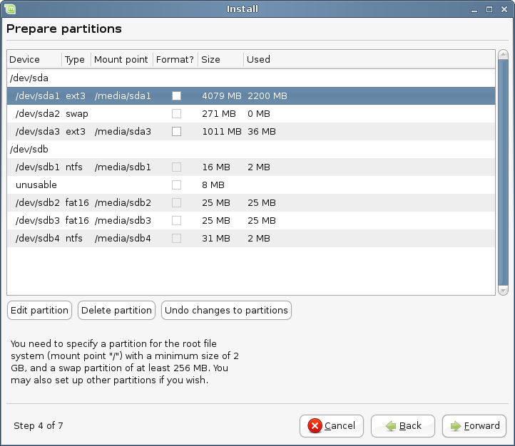

You should now see a table showing the partitions of your hard-drives. In the example above we can see 2 hard-drives (/dev/sda and /dev/sdb) with respectively 3 and 4 partitions.

As you can see in this example the first hard-drive has 2 Linux partitions (of type “ext3”) and the second hard-drive has 4 Windows partitions (2 of type FAT and 2 of type NTFS).

In order to install Linux Mint you need to create 2 new partitions, one of type SWAP, and one of type EXT3.

If the existing partitions on your hard-drive take all the space and you can’t create any new partitions, you can “Edit” a partition and change its size.
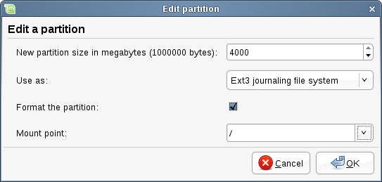
Note: The Swap partition is used by Linux to swap data on the hard-drive when RAM isn’t enough to keep all running applications in memory. The size of your Swap partition should be twice the size of your RAM.

When you create the main partition for Linux Mint make sure to give it 10GB or more (it should fit in 3GB but you’ll probably want to add software to it and it’ll rapidly grow more than 5GB). Also make sure to assign “/” for its mount point and to select “ext3” for its file system.

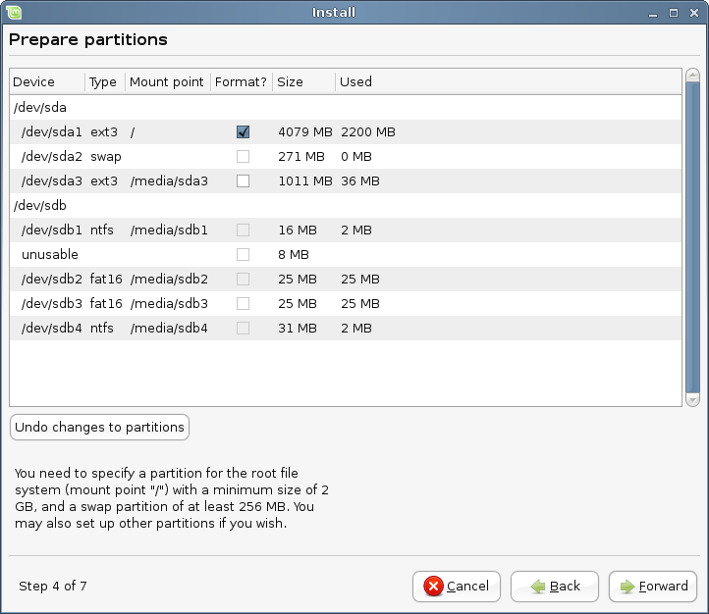

Once all partitions are in place you can select mount points for each of them. Mount points represent the place where these partitions will be visible within Linux Mint. Your default Linux Mint partition should use “/”, other partitions usually use “/media/” followed by their name.

Make sure to select “Format” for the Linux Mint partition but not for the partition you already had.

When ready, close your eyes, say a prayer and click on “Forward”. If this step scared you a little, that's fine. It should bring your adrenaline up a level and make you enjoy the experience even more. Don’t worry, this was the only really complex step in this installation and you should find everything else really easy.

Note: If you see warning messages telling you about cluster sizes and all, simply ignore them.

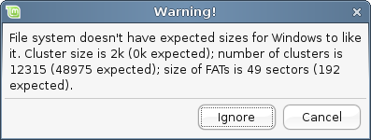

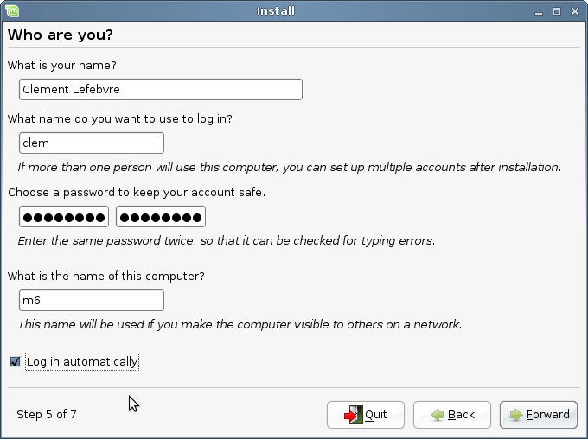
Enter your real name and a username and password. Every time you’ll use Linux Mint you’ll use your account and this username and password. Once Linux Mint is installed you’ll be able to define other accounts if other people are to use this computer.

Also give your computer a name. This name will be used by your computer on the network or in various places of the system. If you’ve never really thought about naming your computers now is the time. People usually pick flower (dahlia, rose, tulip) or planet (mars, jupiter, pluto) names for the computers on their network. It’s entirely up to you what you want to go for but make sure to pick names you like and that you will easily remember.

If you're the only one using the computer and you want to bypass the login screen, check the option “Log in automatically”.

Note: Make sure not to use capital letters in the username or in the name of the computer.

When you’re ready click on the “Forward” button.

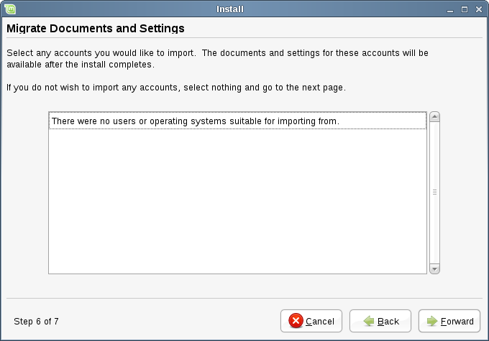
The installer might detect other operating systems on your computer and ask you if you want to migrate some personal information. Typically this allows you to migrate bookmarks, contacts, favorites and other sorts of personal information from Windows, another Linux installation or operating system into the newly installed Linux Mint.

When you’re ready click on the “Forward” button.
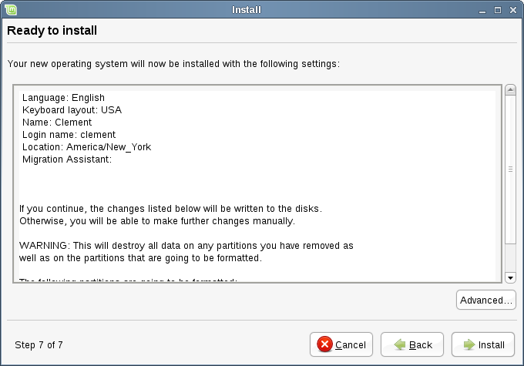
You should now see a summary of all your choices. You could be a little scared about clicking “Install” but you’ve already done that while partitioning and you’re not going to step back now anyway.

There's also an “Advanced” button which lets you do things that are so advanced that if you knew about them you'd probably wouldn't be reading this guide right now :)

When you’re ready click on the “Install Button”.

The installation should take between 10 and 15 minutes.

Note: If you’ve chosen English for the language you can skip the installation of the “language packs” by pressing the “skip” button when it reaches that step.

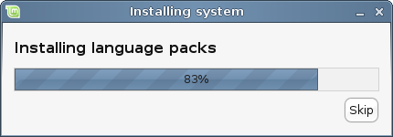

Note: If you’ve chosen a different language the installer will download the packages from the Internet to support the language you’ve selected. Make sure your computer is correctly connected to the Internet for this to work. Otherwise just “skip” that step and you’ll be able to add support for your language after the installation is finished and you’ve rebooted in your new system.

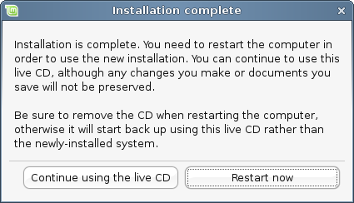

Once the installation is done click the “Restart Now” button and the live system will shut down.

When you see this screen, eject the CD from the drive and press Enter.

Your PC is now ready.

First Boot Configuration

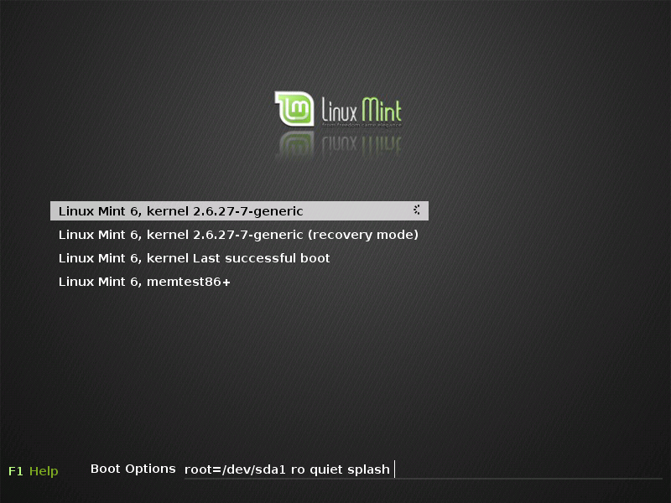
Upon reboot you should see this screen. This is the “boot menu” also commonly called “Grub”. If you have Microsoft Windows or other operating systems installed on your computer Linux Mint should have detected them during the install and they should appear in here.
Linux Mint is now loading. This screen is commonly called “Usplash”.
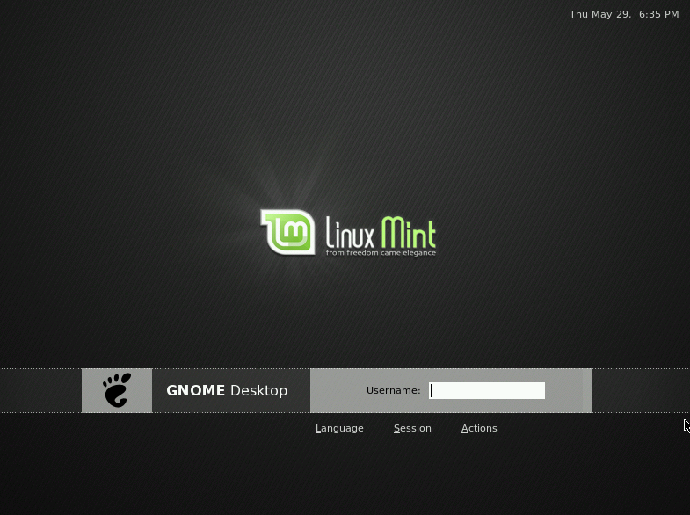
Once Linux Mint is finished loading you should see a new screen inviting you to enter your username and password. This screen is the “Gnome Login Manager” and is commonly called “GDM”. Enter the username and password you chose during the installation.
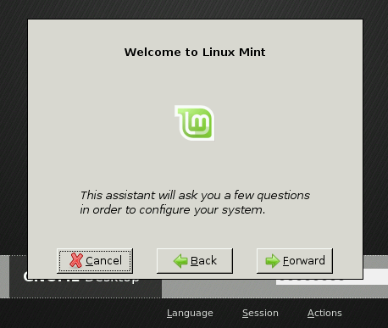

Since it’s your first login and this is some kind of a very special occasion (your very first time with this release) mintAssistant is welcoming you into your new system.
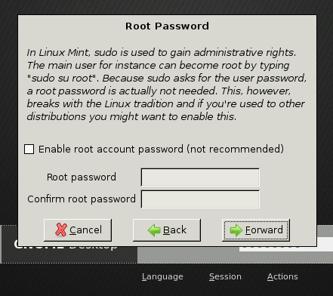

From here you can define a password for the root account. The root account is basically the account of the super-user, the main administrator of the computer. In Linux Mint, the default user (you, in other words) automatically gets administrative privileges so you don’t really need a root account but as most Linux systems work that way you might be tempted to choose this option. If you’re not sure just click the “Forward” button.
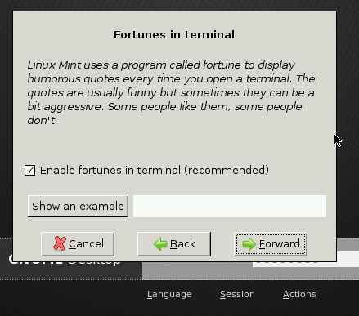

The next step asks you whether you want to see jokes and fortunes appear when you open a terminal. This is entirely up to you and there’s nothing in this guide which will tell you if this is right for you or not. Make your choice and click the “Forward” button.
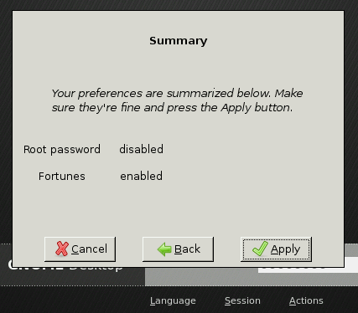

Go through the summary and click the “Apply” button.

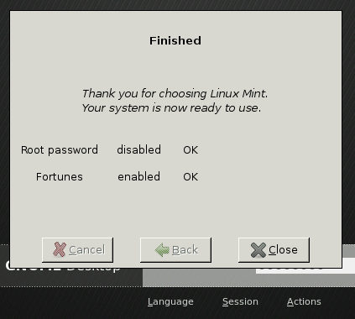
Your Linux Mint system is now ready to be used. Click the “Close” button.

Introduction to the Linux Mint Desktop

This guide will focus on the technologies and the tools that are specific to Linux Mint and provide information on some of the applications and technologies included by default in the Main Edition.

The Gnome Desktop
The “desktop” is the component of the operating system which is responsible for the elements that appear on the desktop: The Panel, the Wallpaper, the Control Center, the menus…etc.

The Main Edition of Linux Mint uses the “Gnome” desktop which is easy to use and focuses on making things simple for the user.

You can find the Gnome User Guide at this address: http://library.gnome.org/users/user-guide/

MintDesktop

MintDesktop is a tool developed by Linux Mint which allows you to configure various aspects of your Gnome Desktop.

Launch MintDesktop by clicking on “Menu” (in the bottom-left corner of your screen), then select “Preferences” and click on “MintDesktop”.

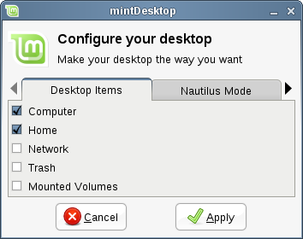
The MintDesktop interface is very easy to use. The “Desktop Items” tab lets you define which elements are visible on the desktop.

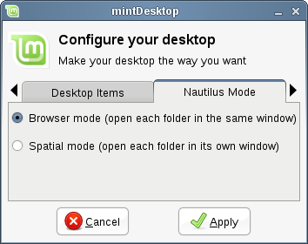
The “Nautilus Mode” tab lets you choose how to navigate through the file system. Nautilus is the name of the Gnome file explorer.

If you choose “Browser mode” Nautilus will use the same window to explore different folders. For instance if we open our home folder and then click on “Documents”, only one window is used.

If you choose “Spatial mode” Nautilus will open each folder in its own window. So if we open Home and then click on Desktop, two windows will be opened, one for Home and one for Documents.

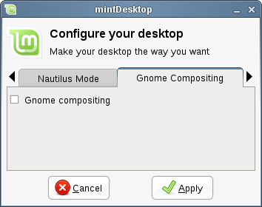
The “Gnome Compositing” tab lets you activate a unique feature in Gnome, its own compositing manager.

Note: The Gnome compositing manager is not very mature yet and doesn't work well with other compositing managers such as Compiz Fusion.

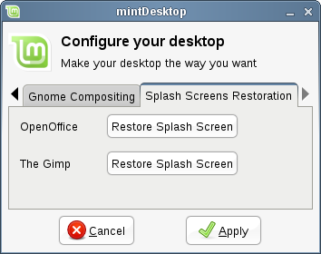

The “Splash Screens Restoration” tab provides two buttons that you can use to restore the splash screens for OpenOffice and the Gimp. Because these applications are maintained by an upstream project (Ubuntu) and not directly by Linux Mint, security updates might change their splash screens.
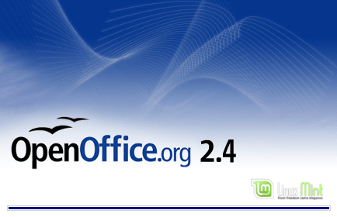
To restore the OpenOffice.org splash screen click on the first button.



To restore the Gimp splash screen click on the second button.

MintMenu
Linux Mint comes with a unique menu system called “mintMenu”. This menu was initially inspired by the “Slab” menu developed by SUSE but differs from it in many ways.

Linux Mint also comes with the default Gnome menu which you can activate to replace mintMenu and we’ll see how to do that later on. MintMenu is worth the learning curve and although it is very different than what you might be used to, you’ll probably love it once you've got used to it.

To open mintMenu click on the “Menu” button at the bottom-left corner of your screen.

Get to know mintMenu

The “Places” menu

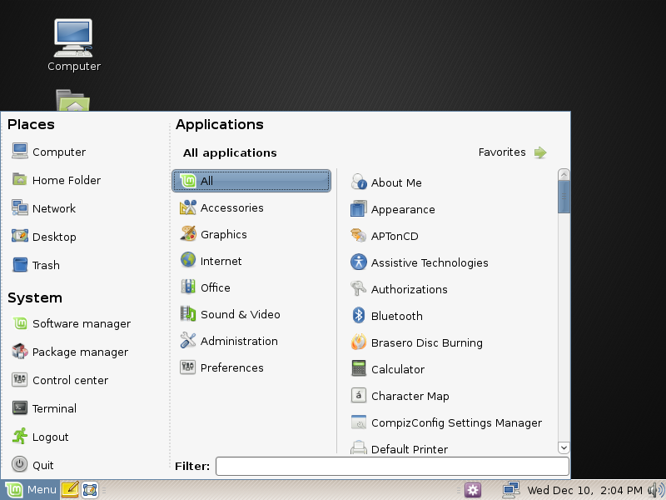
On the top left corner of mintMenu you can see a section called “Places” which provides 5 buttons. These buttons give you quick access to the most important places within your Gnome Desktop.

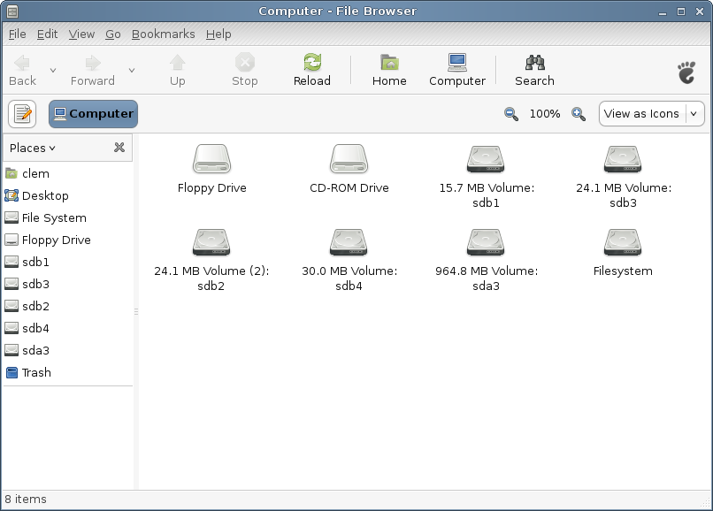

The “Computer” place shows you the storage volumes present in your computer. If your partitions are already mounted and MintDesktop is set to show “Mounted Volumes” on the desktop then you probably don’t need to access this place very often. However, if you choose not to show the mounted volumes on your desktop or if you need to mount a partition which is not mounted by default this place can prove very useful.

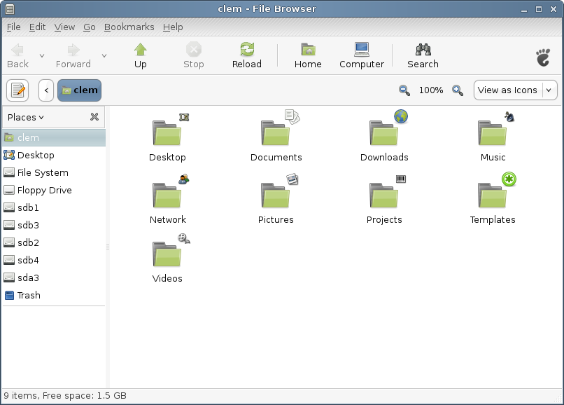

In contrast, the “Home” place is one of the mintMenu buttons you’ll probably use the most. If you’ve used Gnome before, you’re probably used to click on the “Home” icon placed on the desktop. When windows are opened and when the desktop is not completely visible mintMenu can prove useful for you to quickly access your “Home”.

Your “Home” folder contains all your personal data. By default MintDesktop creates a series of folders for you to better organize your files. You can delete these folders if you want or you can use them to separate and store your files according to their type.

The “Desktop” folder corresponds to what is shown on your desktop, so placing a file in there or on the desktop is the exact same thing.

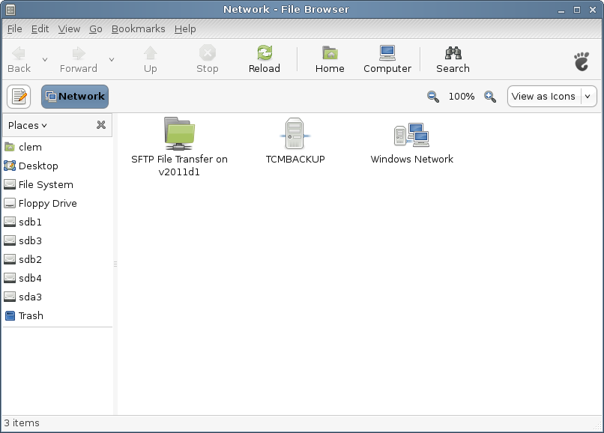

The “Network” place simply shows you the other computers, shared services, domains and workgroups present on your network.

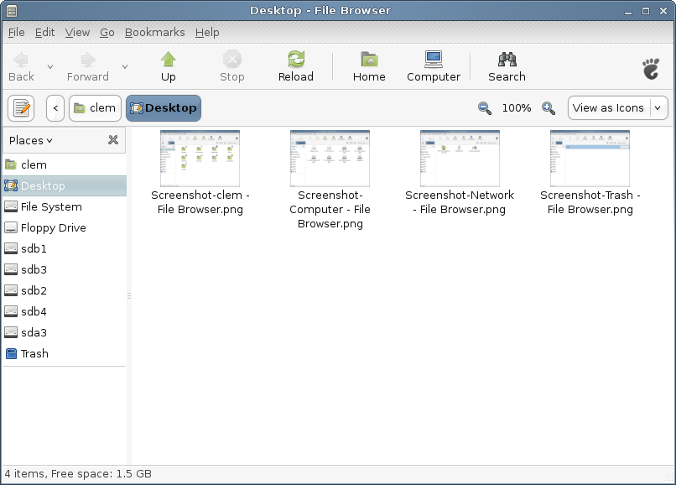

The “Desktop” place shows you all the files that are present on your desktop.

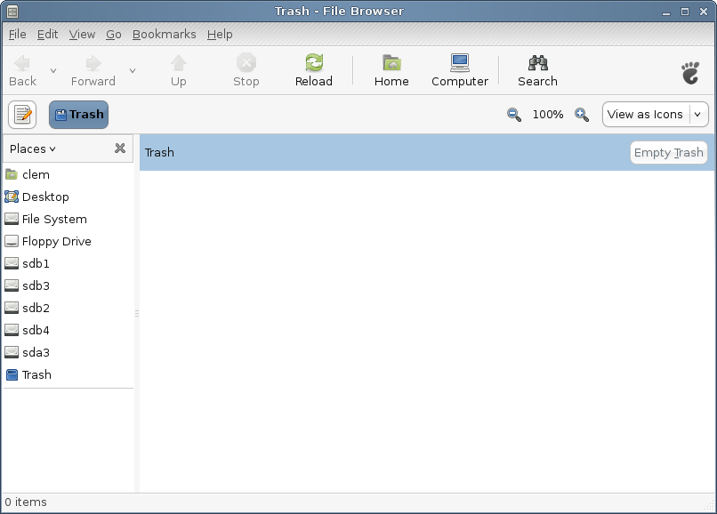

The “Trash” place is where files end up after you delete them.

When you right click on a file you can either “Move to Trash” or “Delete”. If you choose “Delete” the file will be permanently deleted and you won’t be able to recover it. If you choose “Move to Trash” it will be moved to the “Trash” place, accessible from MintMenu. From there you will be able to drag and drop it somewhere if you want to restore it or to “Empty Trash” if you want to permanently delete all elements from the Trash.

The “System” menu

There is a section called “System” in the bottom left corner of MintMenu. This section provides 6 buttons which quickly let you access important features of the system.

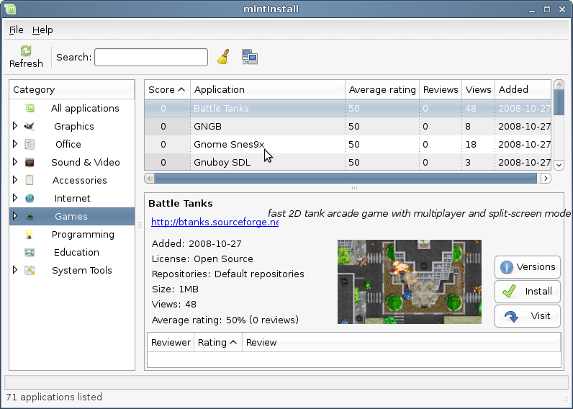
The “Software Manager” button launches a program called “MintInstall”. This program is the recommended way to install software in Linux Mint. As this is developed by Linux Mint we will talk about this more in detail in the next chapters.

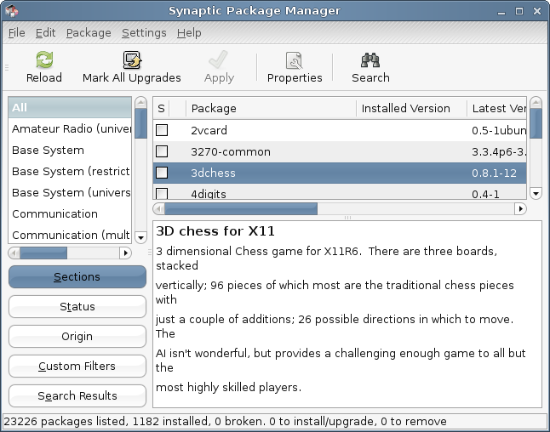

The “Package Manager” button launches an application called “Synaptic”. The purpose of this application is to manage the packages that are installed on your computer and the packages that are available in your repositories. If this doesn’t make much sense yet, don’t worry, we will talk about this in greater details in the next chapters.

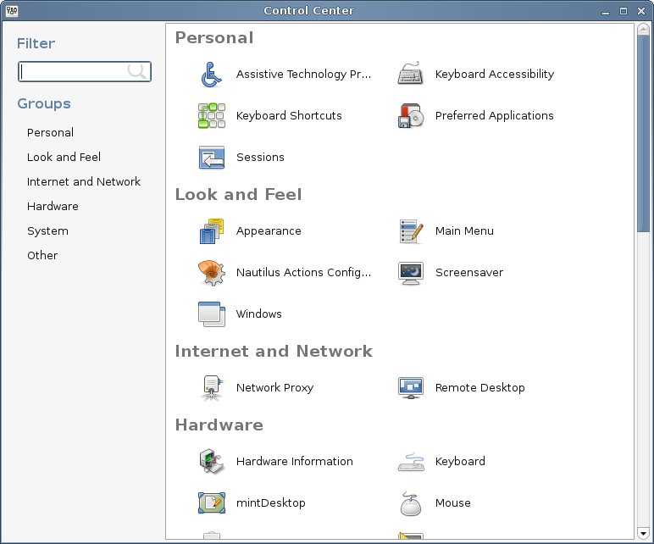

The “Control Center” button launches the Gnome Control Center. This application lets you configure every aspect of the Gnome Desktop and of the computer in General. We will go through each item within this Control Center in the next chapters.

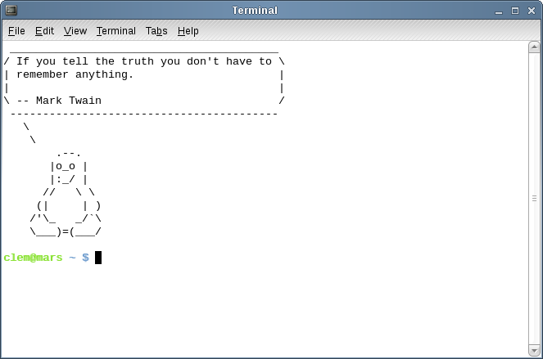
The “Terminal” button launches an application called “Terminal” which lets you enter commands on your computer. If you’re used to Microsoft Windows you’re probably thinking “MS-DOS commands? Give me a break!”. We’d probably agree on the fact that Terminal isn’t the sexiest application included in Linux Mint but you should know it is by far the most powerful and it’s not hard at all to use.

Sooner or later you will have to use this Terminal and the more you’ll use it the more you’ll actually like it (whether you like the idea of liking it … or not). Remember how you didn’t like certain things when you were a kid and how you couldn’t do without them now? Terminal is one of these things. By the end of this guide you’ll be completely addicted to it. You won’t have to use it, you’ll use it because for some tasks it’s actually faster, more accurate and actually simpler to use than equivalent graphical interfaces.

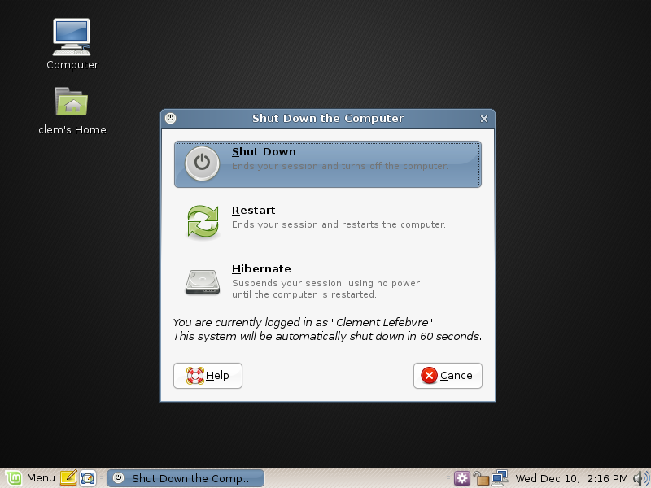

The “Logout” button launches a dialog which lets you logout or switch users.

The “Quit” button launches a dialog box which lets you choose what you want to do:

- “Suspend” saves your session to RAM and your computer goes to sleep until you press a key.
- “Hibernate” saves your session to your hard drive and your computer shuts down.
- “Restart” restarts the computer.
- “Shut Down” turns the computer off.

The “Applications” menu

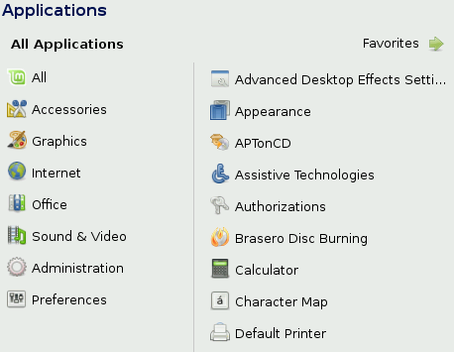
The Linux Mint CD is compressed and actually comes with about 2.5GB of data. The applications that are included by default when you install Linux Mint are said to be part of the “Default Software Selection”.

Since one of the purposes of Linux Mint is to be easy to use and to work out of the box, a collection of software is included by default in order to let you achieve all common important tasks.

In the right hand part of MintMenu you can see all installed applications. They are organized by categories. The first category is called “All” and as you probably guessed it shows you all the applications installed.

The last two categories, “Preferences” and “Administrations”, show you the tools and applications provided to configure and administrate Linux Mint. We’ll focus on these applications later on as they are also present in the “Control Center”.

The 5 categories in the center provide most of the applications you’ll use on a daily basis. As you install new software new categories might appear.

In “Accessories” you can find the following software:

Name | Description
Calculator | A calculator
Character Map | A tool to easily copy and paste special characters (accentuation for instance)
Disk Usage Analyzer | A tool which shows you what takes space on your hard drive.
Gnome Do | A tool to launch actions and programs directly from the keyboard. GnomeDo runs in the background by default so you don't actually need to launch it from here (unless you want to restart it). To make it appear, simply press the SUPER key (the one with a Windows logo on it) and the SPACE BAR.
Manage Print Jobs | A tool which shows the jobs currently active on your printers.
Passwords and Encryption keys | A tool to manage your encryption keys
Take Screenshot | A tool to take screenshots. You can also launch this with the “Print Scrn” key on your keyboard to take screenshots of the desktop, or with “ALT”+”Print Scrn” to take screenshots of the current window.
Terminal | The Terminal
Text Editor | A text editor called “gedit”
Tomboy Notes | An application to take notes
Tracker Search Tool | A tool that lets you search for files and other resources on your computer.

In “Graphics” you can find the following software:

Name | Description
The Gimp | An application that lets you modify, convert or even create pictures. The best Linux equivalent to Photoshop.
OpenOffice.org Drawing | Part of the OpenOffice suite of applications.
Scanner Utility | A tool to capture images from a scanner

In “Internet” you can find the following software:

Name | Description
Firefox | A Web browser
Giver | A quick file-sharing utility
Thunderbird | An Email application
Pidgin | An Internet Messenger (compatible with AIM, Bonjour, Gadu-Gadu, Google-Talk, GroupWise, ICQ, IRC, MSN, MySpaceIM, QQ, SIMPLE, Sametime, XMPP, Yahoo and Zephyr)
Transmission | A Torrent downloader.
Xchat-GNOME | An IRC chat program which automatically connects you to the Linux Mint chat room (very useful if you want to talk to other Linux Mint users).

In “Office” you can find the following software:

Name | Description
Dictionary | A dictionary (requires an Internet connection)
OpenOffice.org Base | A database application (alternative to Microsoft Access).
OpenOffice.org Impress | A presentation application to make slides (alternative to Microsoft Powerpoint and compatible with PPS)
OpenOffice.org Calc | A spreadsheet application (alternative to Microsoft Excel and compatible with XLS)
OpenOffice.org Writer | A word processor (alternative to Microsoft Word and compatible with DOC.)

In “Sound & Video” you can find the following software:

Name | Description
Brasero | A CD/DVD burning application. Brasero can also make audio CDs from multimedia files.
Movie Player | A multimedia application which is associated with most video and audio files (alternative to Microsoft Media Player)
Mplayer Movie Player | An alternative multimedia player. This tool is also used as a plugin within Firefox to play most of the multimedia content.
Pulse Audio Device Chooser & Volume Control | Tools to configure and manipulate the Pulse Audio sound server. For instance, to move one sound stream from the speakers to some USB headset, or from your computer to another one on the network...
Rhythmbox | A music application to play online radio, stream music from the Internet and online music services and to listen to your collection of music files (alternative to iTunes). Rhythmbox also manages podcasts, portable players and can rip CDs.
Sound Recorder | A sound recorder.

The “Search” field

If you can’t remember how to find a particular application within the menu or if you want to get quicker access to it you can use the search feature of MintMenu. Simply click on “Menu” in the bottom-left corner of your screen and start typing the name or a description of the application you’re looking for.

As you’re typing, only the applications matching your search will stay visible within the menu.

Define your favorite applications

You’ll use some applications more than others and so you’ll quickly need fast-access to the applications you’re using the most.

MintMenu lets you define “favorite” applications and gives you fast-access to them.

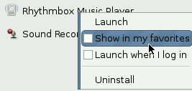

Right click on an application of your choice with MintMenu and select “Show in my favorites”.

You can also drag & drop an application on the “Favorites” button which is situated on the top-right corner of the menu.

Click on the “Favorites” button in the top-right corner of MintMenu and you should now see your favorite applications.

You can right click on your favorite applications to organize them (“Insert Separator”, “Insert Space”), or to remove them from the list of your favorites (“Remove from favorites”).

If you define Favorite Applications MintMenu will show them by default instead of showing the other applications. Of course you can still see the other applications by clicking on the “All Applications” button in the top-right corner of the menu.

Make your own shortcuts

If you don’t like the idea of having “Favorite” applications you can simply use your panel or your desktop to achieve the same thing and to give yourself quick access to your applications. Simply drag & drop the application of your choice from the menu to your panel or to your desktop.

Launch applications automatically when you log in

You can right-click on any application in the menu and select “Launch when I log in”. The application will then be launched automatically, each time after you log in.

Change the appearance of mintMenu

You can customize MintMenu in many ways. Right click on “Menu” and select “Preferences”.

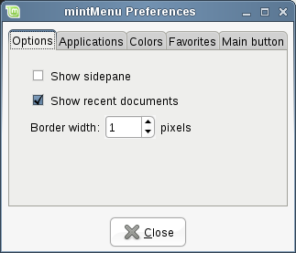
The configuration tool for MintMenu appears. In here you can modify almost every aspect of the Linux Mint menu. Most of the settings take effect immediately, some require mintMenu to be restarted (Right click the menu and select “Reload Plugins”).

Activate the Recent plug-in

MintMenu comes with a plugin which is not activated by default (because it makes the menu bigger). This plugin shows the top 10 most recently opened documents.

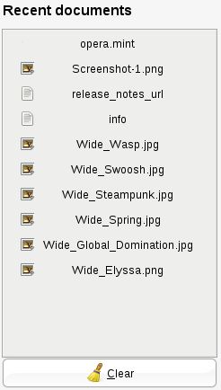
To activate this plug-in, open the MintMenu preferences and select “Show Recent Documents”.

Restore the default settings

If you want to revert to the default settings, right click on the menu button within the panel, choose “Remove from Panel”, then open a terminal and type:

gconftool-2 --recursive-unset /apps/mintMenu

Then right click on an empty part of the Panel and choose “Add to Panel”.

Then select “Linux Mint Menu” in the list.

Replace mintMenu with the default Gnome menu

If you decided you don’t like MintMenu and no matter how cool it is you want to use the Gnome menu instead then follow the steps below.

Right click on the menu button within the panel and choose “Remove from Panel”.

Then right click on an empty part of the Panel and choose “Add to Panel”.

Then select “Main Menu” if you want a simple Gnome Menu, “Menu Bar” if you want the default Gnome Menu or “Linux Mint Menu” if you want to follow our advice even though you don’t like “mintMenu” (which right now wouldn’t make much sense but would still be the right thing to do).

Change other settings

There are a lot of things you can customize in MintMenu and two of the coolest are to show comments in the applications pane, and to use multiple columns for your favorite applications. Both settings are accessible from the mintMenu preferences.

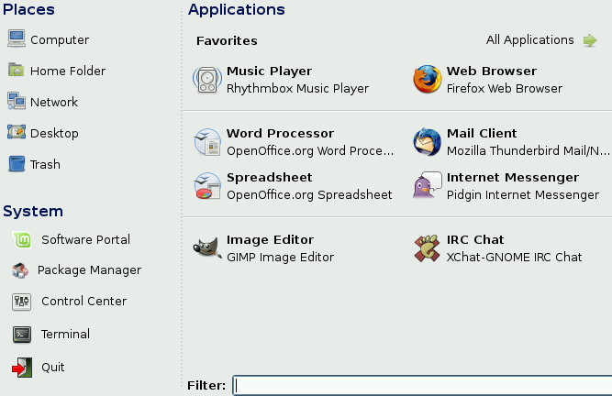
In the example above we’ve set the number of columns to 2. We’ve defined 8 favorites and carefully organized them. You can see how this lets us fit more favorite applications in the same amount of space.

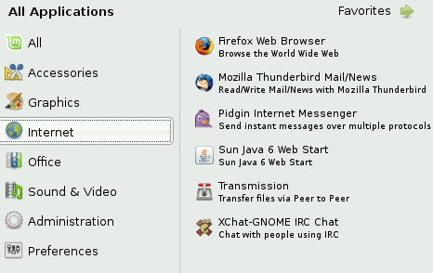
In the example above we’ve told MintMenu to show comments under the applications. This makes the menu look busier but also provides more information about each application.

Install/Remove Applications

Package Management in Linux Mint

If you are used to Microsoft Windows you’re probably not familiar with the concept of “packages”. In fact Package Management is probably the single most lacking feature in Microsoft Windows and the reason why it’s so vulnerable.

If you install Windows on a computer you’ll realize it doesn’t come with a lot of software. There are many files you won’t be able to read, many websites you won’t be able to browse and many basic tasks you won’t be able to perform. There might even be many of your devices of hardware component which won’t even be detected. So after you’ve spent some time installing the proper drivers you’ll find yourself go from one website to another in search of 3rd party software… you need a decompression tool, an office suite, an antivirus, etc… The problem with this is simple: You run a specific version of Windows which was tested by Microsoft. When you add to it some software from another editor, are you sure this editor tested his software for your specific version of Windows? Were the interactions between this software and other software you installed tested as well? And ultimately… can you trust this editor? You can certainly trust Mozilla, OpenOffice, IBM and other famous editors, but what about unknown shareware vendors or even what about Antivirus makers?

Another problem with the way software is installed in Windows is the fact that Windows doesn’t manage it. The software itself dictates how it is updated or if it is at all. You have no way of keeping all your software up to date.

Another problem with the way software is installed in Windows is the fact that most software installations are static. Most applications come in the form of huge exe files or archives which don’t only contain the software you want but all the necessary libraries for it. Of course the more you install software the more you have software applications which come with the same libraries… and of course when you update one of them it doesn’t update the others.

Software management is radically better in Linux and in all modern operating systems. Packages define pieces of software which can depend on each other or one another. Linux distributions usually maintain all the software you need and guarantee this software has been tested and packaged for your release and your distribution.

So for instance, when you install Opera, Real Player or Google Earth in Linux Mint, these applications do not come from Opera, Real or Google. Of course the upstream application comes from these editors, but only after they’ve been properly packaged and tested do they become available for you. So in other words, you should never need to go and browse the Internet to look for software, everything you need is there already tested for you and for your system and all you need to do is to install the right packages.
Linux Mint will update itself automatically through a tool called mintUpdate which will not only update the operating system but all the software installed on your machine as well.

If you’re only finding out about this now and you’re wondering how you could have spent all this time under Windows without a package manager, the answer is “We don’t know. It beats us as well how Vista didn’t come with that since this was introduced in Linux in the early 90s.”

So anyway, enough sarcasm! Let’s see how to install software in Linux Mint, how to remove applications and how to keep everything up to date.

Install new applications

Some of the most popular applications which are not installed by default in Linux Mint are Opera, Skype, Acrobat Reader, Google Earth and Real Player. You might also want to add games (a lot of nice free games are available for Linux).

MintInstall, the Software Manager

The easiest way to install software in Linux Mint is to use mintInstall, the Software Manager.

Open MintMenu and select “Software Manager”.

The Software Manager lets you browse the software made available for Linux Mint. You can browse by category, search by keyword or sort the software by rating and popularity. The Software Manager synchronizes itself with an online portal called the Linux Mint Software Portal. By logging in the Software Portal you can review and rate software applications.

You can visit the Linux Mint Software Portal at http://www.linuxmint.com/software

Synaptic & APT

If you want to install more than one application or if you’re looking for something which is not in the Software Portal or in the Software Manager, Linux Mint provides two other ways to install software. One is a graphical tool called “Synaptic” and the other is a command line tool called “APT”.

Let’s see how we can install Opera (an alternative to the Firefox Web Browser) with these tools instead:

Open MintMenu and select “Package Manager”.

Click on the “Search” button and select “opera”. Then go through the list of packages and find the one corresponding to the Opera Web Browser. Tick the box and select “Mark for Installation” then click on the “Apply” button.

Now let’s see how we could have installed Opera using the APT command line tool.

Open MintMenu and select “Terminal”. Then type the following command:

apt install opera

Note: Make sure synaptic is closed before using APT. Synaptic is using APT in the background so both can’t run at the same time.

As you can see APT is extremely easy to use but it’s not graphical. It’s OK. If you’re starting with Linux you probably prefer to deal with a graphical interface but as time goes on you’ll prefer things to be fast and efficient and as you can see the fastest way to install Opera is to type “apt install opera”. It can’t be simpler than that.

There is one important difference between the Software Manager and Synaptic/APT though. With Synaptic and APT you basically deal with packages. In our example the Opera application was very simple and was only made of one package which name was also “opera”, but it’s not always like this, and you might sometimes not know what the name of the package is. Sometimes you might not even have access to the packages for a particular application.

The Software Manager is different because it lets you install “applications” by getting the right “packages” for you, not only from the repositories (packages databases) that Synaptic and APT have access to, but also from other places on the Internet.

So you might use the Software Manager for two different reasons:
- Because you’re not used to APT/Synaptic
- Because it can actually install applications you don’t have access to using other tools.

Remove applications
Removing an application is quite easy in Linux Mint. Simply highlight the application in mintMenu, right click on it and select “Uninstall”.

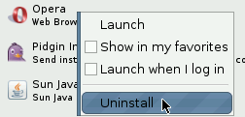
MintMenu finds the packages and dependencies related to the application you selected.

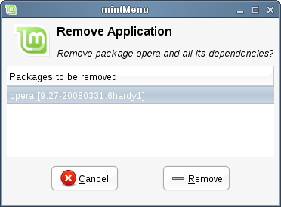
Click “Remove” and the application will be uninstalled.

APT

Another way to remove applications is by using APT. Again, we’re talking command-line utility here, but see how surprisingly easy this is:

Open MintMenu and select “Terminal”. Then type the following command:

apt remove opera

Note: Make sure synaptic is closed before using APT. Synaptic is using APT in the background so both can’t run at the same time.

And that’s it. With one single command you’ve removed Opera from your computer.

Synaptic

And you can also use Synaptic to remove packages... Linux is all about choice so let’s see how to do this.

Open MintMenu and select “Package Manager”.

Click on the “Search” button and select “opera”. Then go through the list of packages and find the one corresponding to the Opera Web Browser. Tick the box and select “Mark for Removal” then click on the “Apply” button.

Update your system and your applications

If a new version of any package installed on your computer is made available you can upgrade to it. It can be a security update for some component of the operating system, it can be an optimization in one specific library or it can even be a newer version of Firefox. Basically, your system is made of packages and any part of it can be updated by getting a package update. This means replacing the current package with a newer version.

There are many ways to do this but only one of them is recommended.

You could use APT to upgrade all your packages with one simple command (“apt upgrade”) or you could use Synaptic and click the “Mark All Upgrades” button but we strongly recommend you don’t do that. The reason is simply because these tools don’t make any distinctions when it comes to applying updates and assume that you want all of them.

Some parts of the system are safe to update and some others aren’t. For instance, by updating your kernel (the part which is responsible among other things for hardware recognition) you might break your sound support, your wireless card support or even some applications such as VMWare or Virtualbox which are closely linked to the kernel.

Using mintUpdate

Linux Mint comes with a tool called MintUpdate. It gives more information about updates and lets you define how far you want to go with applying them. It looks like a lock and sits on the bottom-right corner of your screen.

If you place your mouse pointer on top of it, it will tell you whether your system is up to date or if some updates are available.

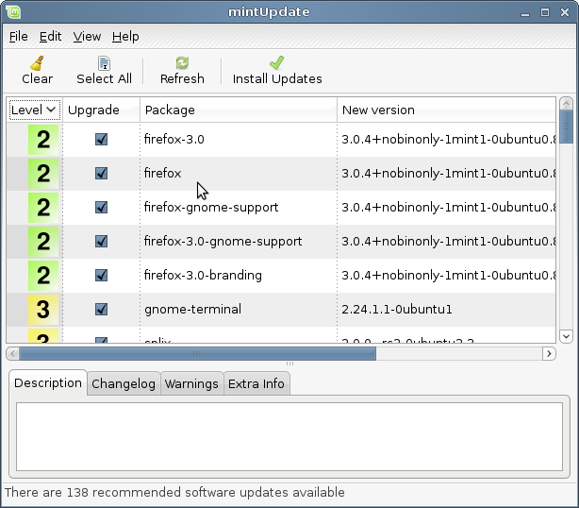
If you click on the lock MintUpdate opens and shows you the updates that are available. The interface is very easy to use. For each package update you can read the description, the changelog (this is where developers write their changes when they modify the package), and eventually if Linux Mint assigned warnings or extra information about the updates. You can also see which version is currently installed on your computer and which version is available for you to update to. Finally, you can see the stability level assigned to the package update. Each package update brings improvements or fixes security issues but that doesn’t mean they’re risk-free and can’t introduce new bugs. The stability level is assigned to each package by Linux Mint and gives you an indication of how safe it is for you to apply an update.

Of course you can click on the columns to sort by stability level, status, package name or by version. You can select all updates or unselect all of them by using the “Clear” and “Select All” buttons.

Level 1 and Level 2 updates are risk-free and you should always apply them. Level 3 updates “should be safe” and although we recommend you take them make sure you go through the list of updates. If you experience any problem with a particular Level 3 update the Linux Mint development team can take measures to make that update a Level 4 or a Level 5 to warn or even discourage other others to take it as well.

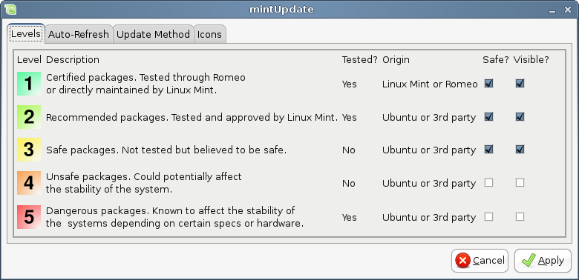

If you click on the “Preferences” button you should see the screen above. By default MintUpdate tells you about Level 1, 2 and 3 updates. You can decide to make Level 4 and 5 “visible”. This will consequently make more updates appear in the list. If you want to (although this is not recommend at all) you can even make Level 4 and 5 updates “safe”. This will consequently make them selected by default within MintUpdate.

MintUpdate only counts “safe” updates. So when it tells you your system is up to date, it means there are no updates available assigned with a level that you defined as being “safe”.

MintUpdate only shows “visible” updates in the list.

For example, if you made all levels “visible” and only Level 1 and 2 “safe”, you would see a lot of updates in the list, but MintUpdate would probably tell you that your system is up to date.

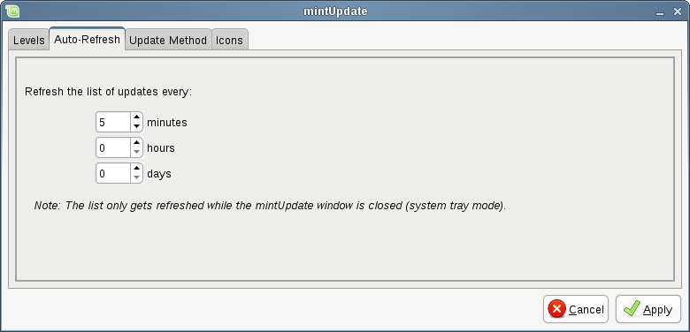
The “Auto-Refresh” tab allows you to define how often MintUpdate checks for updates.

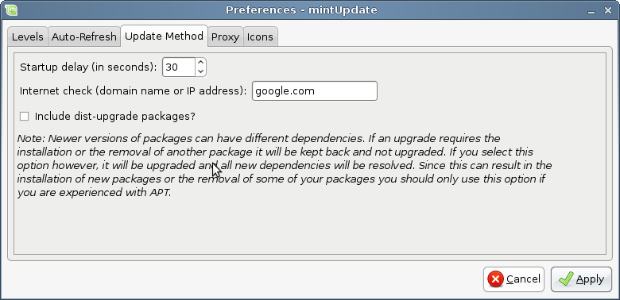
The “Update Method” tab lets you define how mintUpdate checks for new updates.

The “Startup delay” is the amount of time mintUpdate waits before checking for an Internet connection. This delay is used to give the Network Manager an opportunity to establish a connection when the computer starts.

You can also define which domain name is used by mintUpdate to check the connection to the Internet. MintUpdate will try to ping this domain before looking for updates.

The “Include dist-upgrade packages” option allows you to define whether MintUpdate should install new dependencies or not. For instance if packageA version 1 was installed on your computer and packageA version 2 became available, but version2 had a new dependency on packageB which isn’t installed on your computer… what would happen?

If you left this checkbox unchecked version 2 would not appear as an update in the list of updates.

If you checked this checkbox it would and if selected it would install packageB as a dependency.

Be careful with this option as dependency can install new packages on your behalf but they can also sometimes remove packages you already have installed.

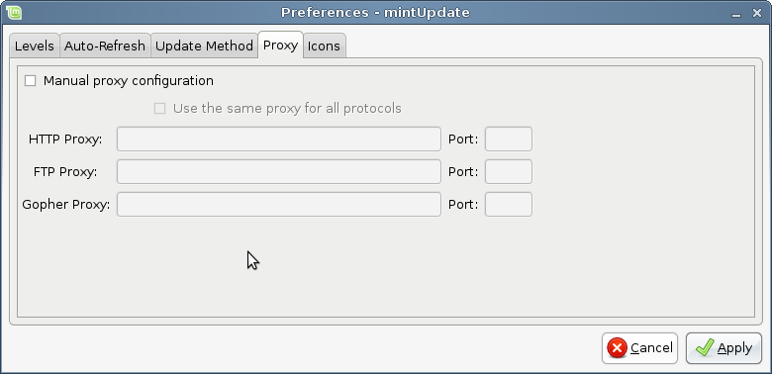
The “Proxy” tab lets you define proxy settings.

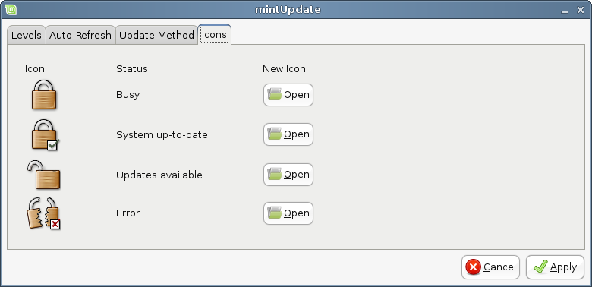

The last tab lets you change the icons used by MintUpdate in the system tray.

Note: If you get errors with MintUpdate (“Can’t refresh list of packages” for instance) you can check the logs for MintUpdate. Right click on the lock icon in the system tray and select “Information”. The following screen appears:

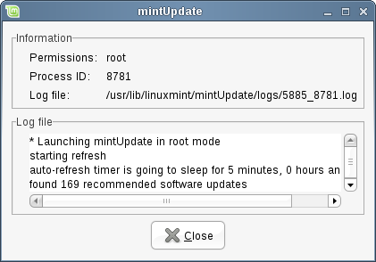
In this screen you can see the process ID of mintUpdate, whether it's running with user or root permissions, and the content of its log file.

You can also review the updates that were applied on your system (provided they were applied via mintUpdate) by clicking on “View->History of Updates”.

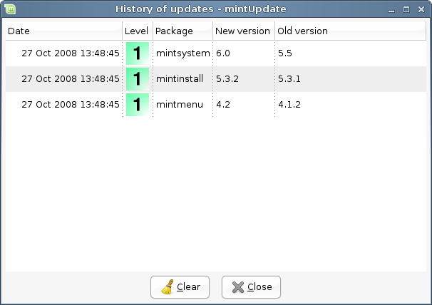

Make the most of your desktop

Are you making the most of your desktop? Do you usually press “CTRL+C” on your keyboard to copy some text? Do you open a text editor to take a quick note? How do you share files with your friends? There are many ways to perform simple tasks, some more handy than others. This chapter is going to show you a few particularities of Linux, Gnome and the Linux Mint desktop, to make sure you make the most of your system.

Copy and paste with the mouse

Most people are used to click on some “Edit” menu or to right click on the content they want to copy. In Linux Mint you can do this as well, just as you would under Windows. But most GNU/Linux operating systems also let you copy and paste content from the comfort of your mouse. Here's how it works: The left button of the mouse copies and the middle button pastes. It's as simple as that!

Let's give it a try. Launch OpenOffice Writer or a text editor, or any application of your choice which lets you input text. Now write a few sentences. Select some text with the left button of your mouse. In Windows you would select some text, click on the “Edit” menu and press “Copy” from there. Some advanced users would use a combination of keys on their keyboard such as “CTRL+C”. In Linux this is much simpler. Just by selecting the text you've already copied it. That's right... that text is now copied within your “mouse buffer”, you don't need to press anything else.

Now click on some other part of the document to move the cursor somewhere else, and click on the middle button of your mouse (or the wheel-click if you have a mouse with a wheel, or both the left and right buttons together if your mouse only has two buttons). As you can see the text you previously selected has now been pasted.

The more you get used to this the faster you'll get at copying and pasting content. This technique also works on most Unix and GNU/Linux operating systems.

Note: The buffer used by the mouse is not the same as the one used by the Gnome desktop. So you can actually copy something with your mouse and copy something else with “CTRL+C” or with the “Edit” menu. Thanks to this you can copy two elements at a time and depending on how you copied them you can paste them with either the middle mouse button or with “CTRL+V” or the “Edit” menu.

Takes notes with Tomboy

We all take notes. Whether it's an address given by someone over the phone, an ever-growing TODO list or some particular thing to remember, we're often faced with the situation where we need to take a quick note. Some of us have a lot of written notes around the computer and never seem to find a working pen when the situation arises, others waste time in launching tools that are not suitable for this particular use (OpenOffice Writer for instance is not very handy to take notes) and very few people actually use software dedicated to note-taking. In Linux Mint, the application which is dedicated to that is called Tomboy Notes. It sits on the bottom left corner of your screen.
Tomboy Notes is a very easy tool to use. By clicking on it you get a list of all your notes. You can create new notes by clicking on “Create New Note”.

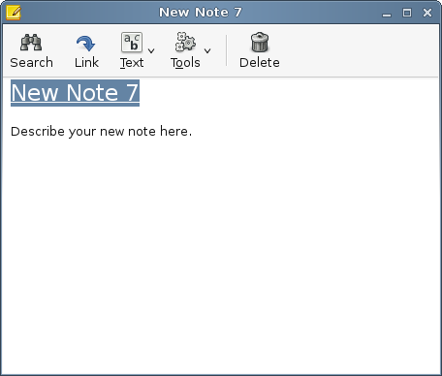
A new note opens up. By changing its title you'll also change its name. You can write whatever you want in the note and close it without saving it. The content you wrote in your note will always be accessible through Tomboy Notes, you don't need to save anything, you can even reboot or turn off the computer. Your note doesn't need to be saved, it's saved automatically as you're writing it.

If you eventually decide that you don't need to keep a particular note anymore you can open that note and click on the “Delete” button.

If you write down the name of another note's title within your note, Tomboy will automatically create a link to that other note and you'll be able to click that link to open the other note.
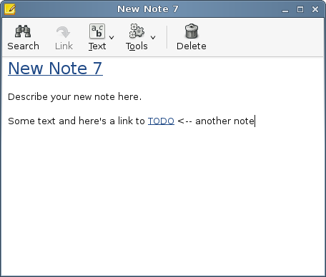
You can also use different formatting options within your note and use the many features provided by Tomboy Notes (synchronization, search features, export notes to PDF/HTML...etc).

Share files with mintUpload

It's easy to send a spreadsheet or a document to someone. You just open the mail application and send it as an attachment. But what if you want to send the pictures from your last holidays? Or a video? Will that fit in an email? Will the size of the files be a problem? Of course it will. Emails and attachments are fine as long as the attached files are light. If you want to send large files, generally bigger than 1MB then you need to find another way.
Most people use an on-line service for this, picasa.net for their pictures, youtube.com for their videos but if all you want is to send these files and not necessarily publish them on-line this solution isn't ideal. Other people use upload services which are generally full of advertisements, of restrictions, not handy for both you and the persons you want to send the files to (need to login, etc..) and also not integrated with your desktop.
In Linux Mint the process of sharing large files was made easy. You can right click on any file and select “Upload”. This will launch an application called mintUpload.
MintUpload works with an on-line service managed by linuxmint.com which doesn't require any login or any registration. Within mintUpload, this service is called “Default”. Right-click on a file, select “Upload” and when mintUpload appears select the “Default” service.
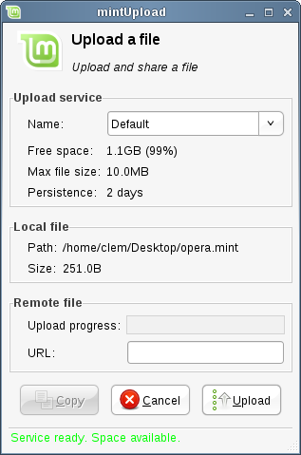

MintUpload will ask the service if there is enough space on-line to store your file. If there is you will be able to click on the “Upload” button.
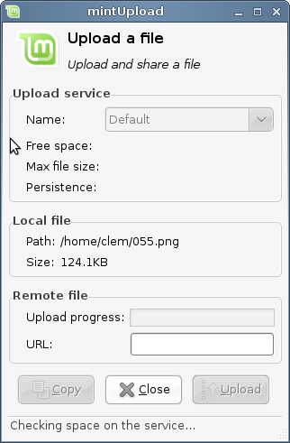
A progress bar should tell you about the upload progress and when the file is fully uploaded an address should appear in the “URL” text field. This address is the location from where people can download your file. Click on the “Copy” button to copy the value of that address in the clipboard.

The Default service accepts files smaller than 10MB and for a duration a 2 days (after this duration the files are generally deleted to free up space on the server).

Use a Mint-Space account with mintUpload

MintUpload is also compatible with Mint-Space accounts and if you own a Mint-Space account you can add it to MintUpload as an extra service. Unlike the “Default” service where files are stored on shared public space, using your own Mint-Space account as a mintUpload service allows you to have your files stay on the server for as long as you want and without any limit on the size of the file. This is like having an FTP client directly integrated with your desktop and working with your own on-line storage.

You can purchase a Mint-Space account for about $30/year from here:
http://linuxmint.com/store.php

In order to use your Mint-Space account with mintUpload, you need to create a new service file. Open a terminal and type:

sudo gedit /usr/lib/linuxmint/mintUpload/services/MintSpace

A text editor should appear, insert the following lines:

name=MintSpace
host=your_domain_name.com
user=your_user_name
pass=your_password
space=http://customer.files.mint-space.com/getfreespace.php?account=your_user_name
url=http://customer.files.mint-space.com/getfile,<TIMESTAMP>,<FILE>,your_user_name.html
path=mintupload
maxsize=1000000000
persistence=9999

Make sure to replace the words in bold with the appropriate information related to your Mint-Space account. Save the file and close the editor. Then open a terminal and type:

sudo rm -f /usr/lib/linuxmint/mintUpload/services/MintSpace~

Right click on a file and select “Upload”. You should now see “MintSpace” in the list of services.
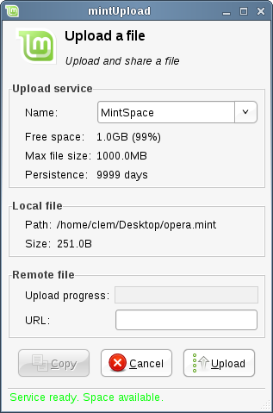
MintUpload is now configured to work with your MintSpace account and you can take advantage of your 1GB storage space to upload as many files as you need. Uploaded files are stored in a directory called “mintupload” within your account and they stay there until you decide to delete them.

Use an FTP account with mintUpload

If you've got access to an FTP server you can configure mintUpload to make use of it. All you need to do is to create a file in /etc/linuxmint/mintUpload/services (or in ~/.linuxmint/mintUpload/services if you want to be the only user to be able to use that service).

Here's an example of such a file:

type=FTP
name=My own FTP server
host=myhost.com
user=myusername
pass=mypassword
path=somedirectory

Note: “path” is optional. If you omit this line mintUpload will upload files directly in the root folder of your FTP account.

Archive emails and websites as PDF

Do you bookmark web pages when you want to read them later? Do you keep old emails in your inbox when they contain some information you might need to remember? Are your inbox and your bookmarks cluttered with things you don't need but don't want to risk loosing? Shouldn't you store this kind of information somewhere else? Of course you could use Tomboy Notes for this but pasting an entire article from the Web to a note is not exactly ideal, you'd loose the pictures, the layout and a lot of information. Why not just print the content instead? Not on paper, but as a PDF file...

Linux Mint comes with a default printer installed. This printer takes the output of the application you're using and sends its content to be stored within a PDF file. So for instance, if you've just booked a flight on the Web and you were given a flight reference sheet and a registration ID just hit the file menu and select print.

Choose the “Print_to_PDF” printer and click on the “Print” button.

The page you were looking at will be printed within a PDF document stored in your Home folder.

Similarly you can print emails from Thunderbird or any kind of content from any application and have the content stored in a newly generated PDF file within your Home folder.

Conclusion

There's a lot more to learn about Linux Mint and about Linux in general. This guide was just an overview of some of the aspects related to your desktop and by now you should feel more comfortable about using it and you should have a better understanding of some of its components. Where are you going to go next? Will you learn how to use the terminal? Will you give other desktops a try (KDE, XFCE..etc)? It's entirely up to you. Remember, Linux is about fun and people are here to help. Take your time and learn a little bit every day. There's always something new no matter how much you know already.

Enjoy Linux and thank you for choosing Linux Mint.

