
Drawing In Writer
Table of Contents
Open A New Text Document 1
Place The Drawing toolbar On Your Screen 1
Draw Two Rectangles 1
Add Color 2
Use The Drawing Object Properties Toolbar. 2
Use The Right-Click Menu 2
Change The Size And Position Of A Rectangle 3
By Using “Position And Size” 3
By Using The Mouse 4
Save The Rectangles In the "Gray Rectangle" File 4
Use The "Gray Rectangle" In Another Document 5
Within Writer, the word processing feature of OpenOffice, there is the ability to make simple drawings. More complex drawing can be done in the Draw feature of OpenOffice.
This tutorial will open the Draw Functions toolbar then draw two Rectangles. These Rectangles will be modified as to size, color, and location on the page.

Open A New Text Document
Click File > New > Text Document. appears on the screen.

Place The Drawing toolbar On Your Screen
- Click on the Show Draw Functions icon, . (The Drawing toolbar appears at the bottom of your screen.)
- To close the Drawing Toolbar when you are done, click the .

Draw Two Rectangles
- On the Drawing Toolbar, click the Rectangle icon.
- Without pressing any button on the mouse, move the mouse so that the pointer is about one inch below the top margin and about one inch in from the left margin. (The pointer will change into 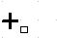 when the pointer is anywhere on the page.)
- When the is at the proper location, do the following: Press and keep holding down the left button on the mouse, then move the mouse down and to the right. (As you move the mouse, a rectangle will appear.) When the rectangle is about two inches across and one inch down, release the left button of the mouse. (A rectangle will be placed on the page and it will have green squares called handles on the edges.)
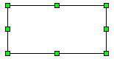
- Without pressing any button on the mouse, move the pointer to the right so the is about 1 inch from the rectangle. Draw a second rectangle as done in Step 3, above. (A second rectangle appears to the right of the first one.)

Add Color

Use The Drawing Object Properties Toolbar.
- In the Draw A Rectangle exercise above, when you clicked on the rectangle in the Drawing toolbar, the Drawing Object Properties toolbar appeared at the top of your screen below the Formatting toolbar.
- The 2nd rectangle should still have the eight green handles indicating that the 2nd is selected. Click in the Area Style/ Filling dialog box which is just to the right of the Area icon.
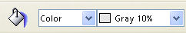
- Click the to select Color in the first Area Style / Filling dialog box. In the second Area Style / Filling dialog box, click the to select Gray 10%.
- Your 2nd rectangle is now gray.

Use The Right-Click Menu
- Keep the pointer anywhere on the gray rectangle, then right-click. (A menu appears.)
- Click on the word Area. (The Area window appears)
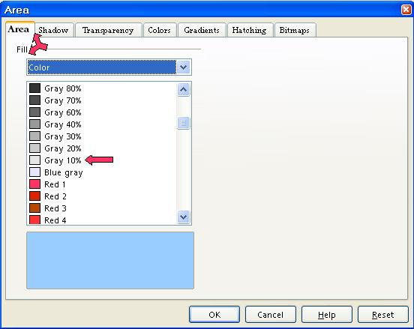
- Click on the Area tab.
- Scroll until you can see the words Gray 30%. Click on Gray 30%, then click the OK button (Your 2nd rectangle is now a darker gray than before. )

Change The Size And Position Of A Rectangle

By Using “Position And Size”
We are going to make the gray rectangle, 1 inch wide by 2 inches high, and place the rectangle 3.0 inches from the left margin and 1.5 inch from the top margin.
- Right-click anywhere on the gray rectangle. (A menu appears.)
- Click Position and Size. (The Position and Size window appears.)
- Click on the Position and Size tab. In the Size section, set the Width to 1.0. (The cursor is flashing just before the numbers in the Width box. Type 1.0, then press the Del (delete key) enough times to delete the original number.)
- Set the Height to 2.0. (In the Height box, click just before the number, type 2.0 then delete the old number with the Del key)
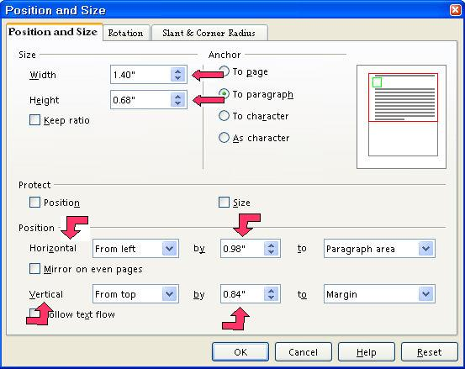
- In the Position section, change the Horizontal setting as follows: In the by box, change the number to 3.0. (In the "by " dialog box, click just before the number. Type 3.0, then press the Del key to delete the original number.)
- Change the Vertical setting as follows: In the "by" dialog box, click just before the number. Type 1.5, then press Del to delete the original number.)
- Click the OK button. (The rectangle changes size and location.)

By Using The Mouse
- To move the gray rectangle, click in the gray rectangle. (Your mouse pointer becomes .) Drag the gray rectangle to a different location by dong the following: Keep the pointer on the gray rectangle. Press and keep holding down the left button on the mouse, then move the mouse in any direction to reposition the rectangle. Release the mouse button. The rectangle is moved to a new location.)
- To resize the gray rectangle and still keep the proportions of the rectangle, click in the gray rectangle. Press and keep holding the Shift key then click and drag a handle of the rectangle. Release the mouse button to complete the resize. (The size of the rectangle changes and is not distorted.)

Save The Rectangles In the "Gray Rectangle" File
- Click File > Save As. (The Save As window appears.) If the words, My Documents, are not already in the Save in: dialog box, click the of the Save in: dialog box. (A menu will appear) Find My Documents on this menu and click it. (My Documents will appear in the Save in: dialog box. )
- In the File name: dialog box, type the words, Gray Rectangle. In the Save as type: pull-down menu box, click on OpenOffice Text Document. Click on the Save button. (The Gray Rectangle file has been saved on your computer in the My Documents folder, and can be opened later.)
- in the blue area at the top of your screen indicates the file Gray Rectangle is still open on your computer.
- Click File > Close. (The Gray Rectangle file is closed and is not seen on the screen.)

Use The "Gray Rectangle" In Another Document
- Click File > New > Text Document. appears on the screen.
- Click File > Open. (The "Open" window appears.)
- In the menu below the Look in:" dialog box, click My Documents if it is not already there. In the menu below the File name: dialog box, click Gray Rectangle. (The Gray Rectangle file appears on your screen.)
- Right-click inside the Gray Rectangle. (The green handles and a menu appears.)
- Click Copy. Right-click where you want to place the Gray Rectangle on your new document. Click Paste. (Or you can use the “Copy”, , and “Paste”, 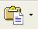, icons on the Standard Toolbar. The Gray Rectangle is now on your new document.)
- Click File > Close > Discard. (When a file has been changed, you will see the message below.)

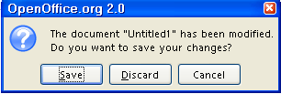

- The document is no longer on the screen.

Notes

Tutorials are improved by input from users. We welcome your constructive criticism.
E-mail suggestions and comments to: contact@tutorialsforopenoffice.org
For other free tutorials go to: http://www.tutorialsforopenoffice.org

This work is licensed under a Creative Commons Attribution 3.0 License

