

CALC
Table of Contents
Insert Large Images In Your Document 3
Insert Small Images To Be In Line With The Text 5
Add/Delete Spaces Between Image And Text 5
Image Too Large Or Too Small 5
THE CALC TOOLBARS 5
THE MAIN MENU TOOLBAR (CALC) 5
THE FUNCTION TOOLBAR (CALC) 5
The Function Toolbar Icons 5
AutoSpellcheck 5
Copy 6
Cut 6
Data Sources 6
Document As Email 6
Edit File 6
Export Directly As PDF 6
Find & Replace 6
Format Paintbrush 6
Gallery 6
Hyperlinks 6
Insert Chart 6
Insert Chart Pointer 6
Navigator 7
New icon 7
Open Icon 7
Paste 7
Print File Directly 7
Redo 7
Save Icon 7
Show Draw Functions 7
Sort Ascending 7
Sort Descending 7
Spellcheck 7
Undo 8
Zoom 8
THE FORMATTING TOOLBAR (CALC) 8
The Formatting Toolbar Icons 8
Align Center Horizontally 8
Align Left 8
Align Right 8
Background Color 8
Background Color Menu 8
Bold 8
Borders 9
Border Color Menu 9
Borders Menu 9
Centered 9
Decrease Indent 9
Font Color 9
Font Name 9
Font Size 10
Increase Indent 10
Italic 10
Justified 10
Merge Cells 10
Styles and Formatting 10
Underline 10
THE FORMULA TOOLBAR (CALC) 10
The Formula Toolbar icons: 10
Accept icon 10
Formula icon 10
Function icon 11
Function Wizard 11
Input Line 11
Name box 11
Sum icon 11
The PAGE PREVIEW TOOLBAR (CALC) 11
The Page Preview Toolbar Icons 11
Close Preview Icon 11
First Page Icon 11
Full Screen Icon 11
Headers & Footers Icon 12
Last Page Icon 12
Next Page Icon 12
Page Icon 12
Previous Page Icon 12
Zoom In Icon 12
Zoom Out Icon 12
Open A New Spreadsheet Instructions And Image 12
Spreadsheet Sheet Navigation 12
Select Sheets 12
The "Delete Contents" Window 13
USER-DEFINED BOX 13
Arrows Showing Where To Click 13
Lines As A Result Of Clicking 13
Drag Copy Pointer 14
Chart Type Icons 14
Chart Type-Areas 14
Chart Type-Columns 14
Chart Type-Bars 14
Chart Type-Lines 14
Chart Type-Net 14
Chart Type-Pies 14
Chart Type-Stock Market 14
Chart Type-XY Chart 14

Insert Large Images In Your Document
Large Images will need to be placed below the paragraphs. For example, the large image below is placed beneath this paragraph.
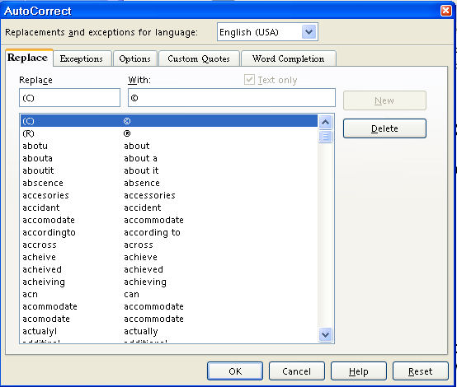
- Open the Navigator Images document
- Open a new document to write your tutorial
- Begin writing your tutorial
- To add the image, do one of the following:
- Right-click on the image in the Navigator Images that you will use. (A menu will appear.)
- Click Copy.
- Go to your document and click where you want the image then right click on your document. (A menu will appear.)
- Click Paste.
- The image is now in your document.
Or
- Click on the image in the Navigator Images that you want to use.
- Click the Copy icon on the Standard Toolbar.
- Go to your document and click where you want the image then click the Paste 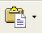 icon .
- The image is now on your document.

Insert Small Images To Be In Line With The Text
Small images can be inserted in line with the text such as this one, the Copy icon.

Add/Delete Spaces Between Image And Text
The images are saved "As Character" and can be moved up or down on your line of text. After insertion, you may delete spaces by clicking the Del key or add spaces by clicking the space bar between the image and your text.

Image Too Large Or Too Small
If the image is too large, there will be additional space between your lines of text. To correct this:
- Click on the image. (The green handles will appear.)
- Place your pointer on one of the handles.
- Hold down the Shift key and drag to make the image smaller.

THE CALC TOOLBARS
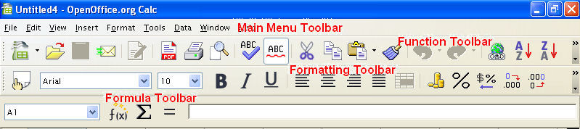

THE MAIN MENU TOOLBAR (CALC)

THE FUNCTION TOOLBAR (CALC)

The Function Toolbar Icons

AutoSpellcheck
The AutoSpellcheck 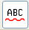 icon

Copy
The Copy icon

Cut
The Cut icon

Data Sources
The Data Sources icon

Document As Email
The Document As Email icon

Edit File
The Edit File icon

Export Directly As PDF
The Export Directly As PDF icon

Find & Replace
The Find & Replace icon

Format Paintbrush
The Format Paintbrush icon

Gallery
The Gallery icon

Hyperlinks
The Hyperlinks icon

Insert Chart
The Insert Chart 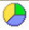 icon

Insert Chart Pointer
The Insert Chart Pointer

Navigator
The Navigator icon 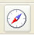

New icon
The New 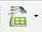 icon

Open Icon
The Open icon

Paste
The Paste icon

Print File Directly
The Print File Directly icon

Redo
The Redo icon

Save Icon
The Save icon

Show Draw Functions
The Show Draw Functions  icon.

Sort Ascending
The Sort Ascending 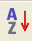 icon

Sort Descending
The Sort Descending 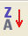 icon

Spellcheck
The Spellcheck icon

Undo
The Undo icon

Zoom
The Zoom  icon

THE FORMATTING TOOLBAR (CALC)

The Formatting Toolbar Icons

Align Center Horizontally
The Align Center Horizontally  icon

Align Left
The Align Left 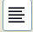 icon

Align Right
The Align Right 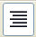 icon

Background Color
The Background Color icon

Background Color Menu
The Background Color 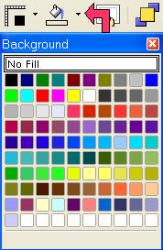

Bold
The Bold icon

Borders
The Borders icon

Border Color Menu
The Border Color 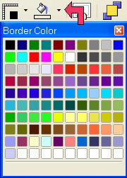 Menu (Line Color)

Borders Menu
The Borders 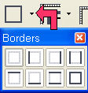 Menu

Centered
The Centered 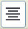 icon

Decrease Indent
The Decrease Indent 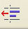 icon

Font Color
The Font Color icon
The Font Color menu 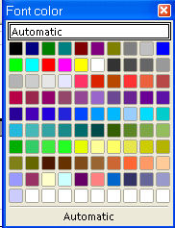

Font Name
The Font Name dialog box

Font Size
The Font Size dialog box

Increase Indent
The Increase Indent 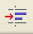 icon

Italic
The Italic  icon

Justified
The Justified  icon

Merge Cells
The Merge Cells icon

Styles and Formatting
The Styles and Formatting icon

Underline
The Underline  icon

THE FORMULA TOOLBAR (CALC)

The Formula Toolbar icons:

Accept icon
The Accept  icon

Formula icon
The Formula icon

Function icon
The Function icon

Function Wizard
The Function Wizard icon

Input Line
The Input Line

Name box
The Name box

Sum icon
The Sum icon

The PAGE PREVIEW TOOLBAR (CALC)

The Page Preview Toolbar Icons

Close Preview Icon
The Close Preview Icon

First Page Icon
The First Page icon

Full Screen Icon
The Full Screen icon

Headers & Footers Icon
The Headers & Footers Icon

Last Page Icon
The Last Page icon

Next Page Icon
The Next Page icon

Page Icon
The Page Icon

Previous Page Icon
The Previous Page Icon

Zoom In Icon
The Zoom In icon

Zoom Out Icon
The Zoom Out icon

Open A New Spreadsheet Instructions And Image
On the desktop, click > All Programs > OpenOffice.org 2.0 > OpenOffice.org Calc. If you are in OpenOffice.org Writer, click File > New > Spreadsheet. (The spreadsheet called appears on our screen.)

Spreadsheet Sheet Navigation

Select Sheets
- You can click on the on the bar at the bottom left on the spreadsheet, (The first arrowhead,, will take you to the beginning of the sheets, the second and third will take you to the previous sheet,, or to the next sheet, , the fourth arrowhead, , will take you to the last sheet.)
- At the bottom of the spreadsheet page, you can check the sheet numbers or names, , to select a sheet.

The "Delete Contents" Window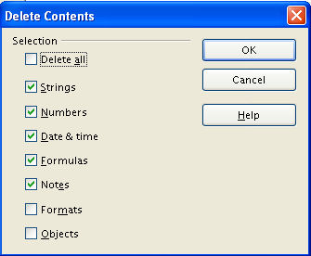

USER-DEFINED BOX

Arrows Showing Where To Click
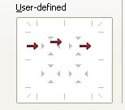

Lines As A Result Of Clicking
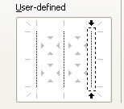

Drag Copy Pointer

Chart Type Icons

Chart Type-Areas 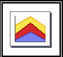

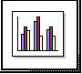
Chart Type-Columns

Chart Type-Bars 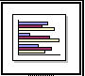

Chart Type-Lines 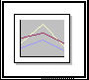

Chart Type-Net 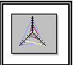

Chart Type-Pies 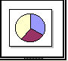

Chart Type-Stock Market 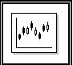

Chart Type-XY Chart 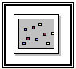

Notes

Tutorials are improved by input from users. We welcome your constructive criticism.
E-mail suggestions and comments to: contact@tutorialsforopenoffice.org
For other free tutorials go to: http://www.tutorialsforopenoffice.org

This work is licensed under a Creative Commons Attribution 3.0 License

