
Automate Slides In Your Presentation
Tutorial Donated by Bill Shelley
Once you have created your Impress Presentation you might now want to automate the slides so that you don't have to click the mouse to move to the next slide every time.

Activity | Explanation
- Click File > Open . | The "Open" window appears.
- In the menu below the Look in: dialog box, click My Documents if it is not already there. In the menu below the File name: dialog box, click the name of your Presentation. . | Your Presentation appears on your screen.
In the Tasks window, click Slide Transition. | The "Tasks" window is on the right side of your "Impress Presentation" screen.
Under Apply to selected slides, click the to scroll to select a transition like Wipe Down or Wipe right. | 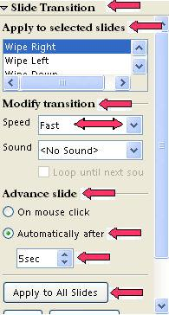
Click the to scroll to Fast in the dialog box to the right of Speed under Modify transition. Click Fast. | In the "Speed "dialog box, you have three choices for the speed of the transition. The choices are "Slow", "Medium", and "Fast".
Click Automatically after in the dialog box below Advance slide. Click the to set the Seconds to 5sec. | You can also highlight the number in the dialog box and type the number of seconds.
Click Apply to All Slides.
Press F5 to view your presentation to see if you have the speed and format the way you want it. If you want to change the speed or the type of transition you simply apply the process again.

Notes
Tutorials are improved by input from users. We welcome your constructive criticism.
E-mail suggestions and comments to: contact@tutorialsforopenoffice.org
For other free tutorials go to: http://www.tutorialsforopenoffice.org

This work is licensed under a Creative Commons Attribution 3.0 License

