Land Use and Misuse Problems in Sudan

Mohamed Elamin Abdelrahman,
Sudan.
Nov. 2006

Key Words:
Land- In its broader sense as defined by FAO(1976), comprises the physical environment, including climate, relief, soils, hydrology and vegetation, to the extent that these influence potential for land use. It includes the results of the past and the present human activity. Land is thus a wider concept than soil or terrain.
Land Use- Means the major kinds of land use such as Traditional Rain fed Agriculture; Rain fed Mechanized Farming, Grass Land, Forestry, Game Reserves... etc.
Ecosystem - It is a dynamic complex of plant, animal and microorganism communities and their non-living environment interacting as a functional unit.
Natural resources - The geophysical of water, soil, vegetation and wildlife.
Sustainability- A characteristic or state whereby the needs of the present and local population can be met without compromising the ability of future generations or populations in other locations to meet their needs.

Summary
Sudan… the largest country in Africa (Approx. 2.5 million sq. km.) is highly diversified in almost all aspects. It endowed with rich and varied natural resources both renewable and unrenewable, for its largeness and diverse physical elements, being reflected by its geological formations, climatic variance, ecological zones, agro-climatic zones, ethnic groups, and abundant water sources, of which the Nile and its tributaries constitute a major feature. Of the total Sudanese people who live in rural areas 64.5% of them, sustain their livelihoods from utilizing the available natural resources.
The sedentary group of these rural people practices agriculture on subsistence basis while the nomadic one depends on communal rangelands in raising livestock.
The modern economic sector has entered the area of agricultural production. As a result, vast tracts of forests and range lands have been brought under plough especially in rain-fed areas. Resources misuse has resulted in severely damaged, degraded environment and desertification has become one of the major problems in the country. However, the ecosystem drivers are still at work and the future seems to look very dim for the rural especially the rural poor.
Land tenure is either traditional (historically derived tribal territorial rights initially constituted during the successive indigenous kingdoms of pre-colonial Sudan. Or modern under which land is registered and considered as government lands.
The objectives of our strategies and policies in the past were to increase the national income. At that time objectives such as conservation of Natural Resources were beyond the conception of those policies. At present issues of Natural Resources conservation, sustainable development, poverty alleviation, community participation, and indigenous knowledge are seriously taken in consideration.
Management systems are mainly the government, non-government organizations (NGO'S) and the community based organizations (CBO'S). The government institutions and NGO'S converge at some points with the communities, reaching them as recipient of development inputs and care-takers of the Natural Resources, through jointly implemented programmes.

1-NATURAL RESOURCES … STOCK TAKING
1.1. Geography
The republic of the Sudan covers an area of approximately 2,506,000 sq. km, lying in north east Africa.
The northern half of the Sudan is classified by UNESCO (1977) as arid and hyper arid, with the rest f the country ranging from arid to semi-arid.
Several geographical regions are usually distinguished, based on the combination of climatic zones and topography. Major distinctive regions are reflected in Map 1: Namely, Desert, Semi-desert, Low rain fall wood land savanna, High rain fall wood land savanna, Flood region And Montane vegetation.

Map1: Sudan Vegetation Zones

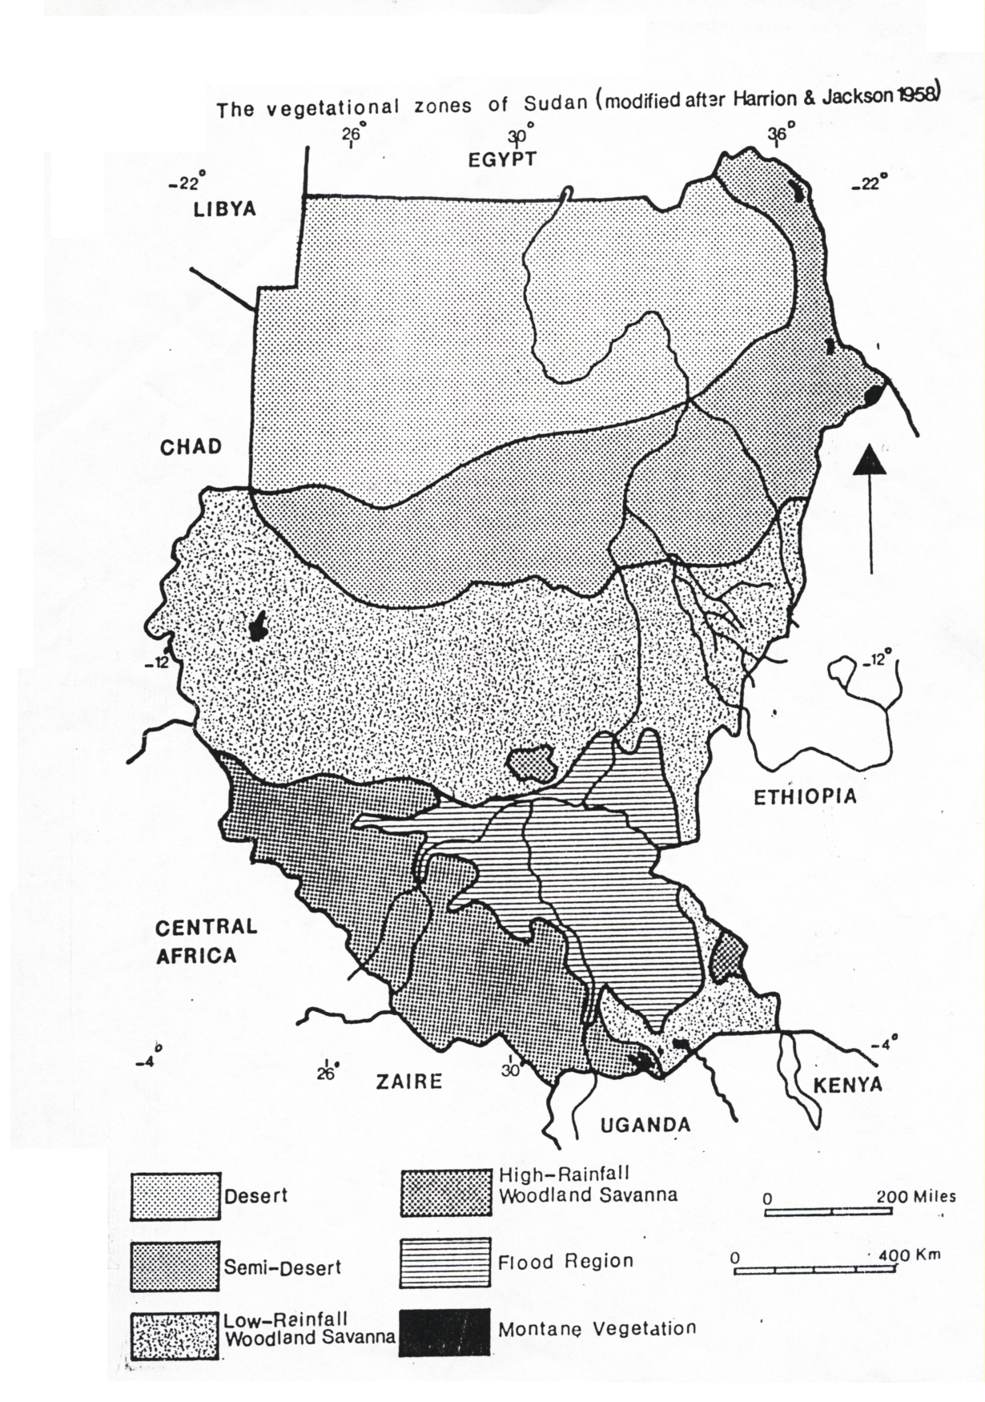
2.1.2 Mountains

2.1.1 North Desert Region
Nearly uninhibited, except for the densely populated Nile valley

1.2 Climate
`1.2.1 Rainfall
Rainfall averages less than 25mm annually in the northern most part of the country. It generally increases towards the south, averaging 200mm around Khartoum, and 800mm on the northern fringe of the swamps. The southern border lands receive over 1400mm annually. (Map: 2).
1.2.2 Temperature
Mean daily temperature is fairly high throughout Sudan, with a maximum in the hottest month of above 40⁰C, throughout the northern half of the country. Generally it ranges from 10-20⁰C in winter, with exception of Jebel Marra, where it is about 6-8⁰C.
1.3 Geology
Excluding the superficial deposits, the most extensive Formation in the country is the Basement Complex. Various Basement Formations occur in different regions of the Sudan. Nubian Sandstone Formations occur widely in the northern and central Sudan, and are probably the most important water bearing formations. Also important on ground water consideration are Um Rruwaba and El Atshan formations which are extensive in the southern half of the country.

Map 2: Mean Annual Rainfall

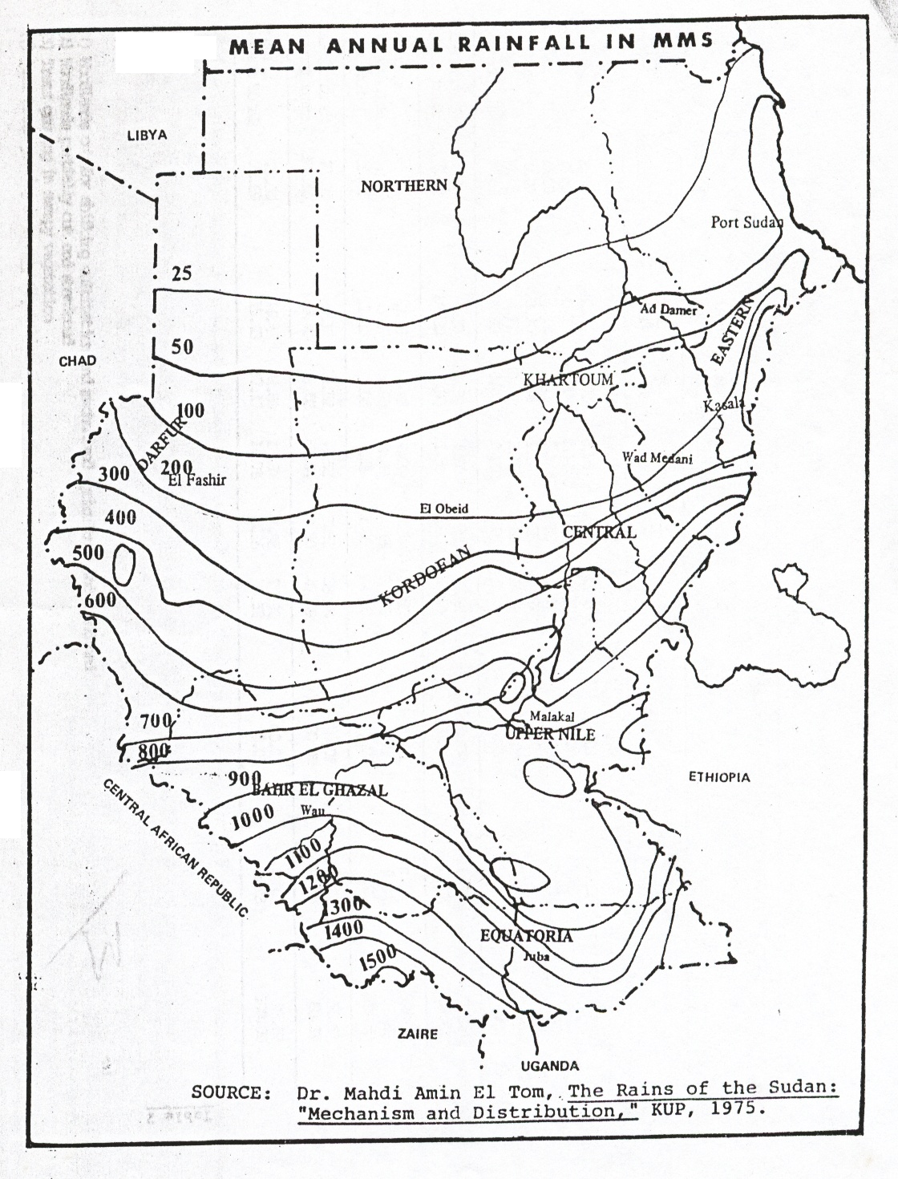

1.4 Soils
The UNESCO-FAO soil map covered Sudan in its Africa sheets (UNSCO-FAO 1971).Nearly 100 soil categories are distinguished within Sudan, which may be broken-down into (Yermesols, Lithosols, Regosols, Xerosols, Arensols, Vertisols, Fluvisols, Ferralsols, Gleysols, Cambisols…etc ). Out of these existing types, 4 merit to be highlighted:-
Xerosols: Extensively utilized as grazing land and for casual crop raising.
Arenosols: Found throughout west central Sudan (Darfur-Kordofan), being extensively used for cultivation, and known to be of poor organic matter content.
Vertisols: Probably the widest spread soils in the Sudan. They are dark cracking clays, very heavy, and difficult to work with traditional hand implements.
Fluvisols: Found throughout the Nile valley and the major Wadies.
1.5 Vegetation
The vegetation may be divided into 5 main zones (Map 1).
1.5.1 Desert Zone
Located north of lat. 17N, excluding the Red Sea Hills. Annual rainfall is less than 50mm. No vegetation in this part, except for a few ephemeral herbs and grasses that grow after the scanty rains, forming what is known as Gizzu.
1.5.2 Semi-Desert Zone
Located between latitudes 14⁰-17⁰N, including the Red Sea Hills. Vegetation is made up mainly of annual and perennial grasses and herbs, with or without woody plants.
1.5.3 Wood Land Savanna Zone
Receives Monsoon rainfall ranging from 300-1200mm. The presence of tall grass species plays an important role in determining the climax vegetation. Most plants are fire resistant, with the vegetation formed of mixed grasses and bushes, with or without trees; and with the zone divided into two sub-types.
1.5.4 Flood Zone
With a total area of 116,000 sq. km. According to the amount of flooding, 3 types of vegetation may be distinguished: high land rarely flooded; intermediate land, flooded during the rainy season; and swamps, of which 13500 sq.km are permanent
1.5.5 Montane Zone
Comprising areas of high altitude, where vegetation changes with height. Of these we mention the Immatong and Dongotona Mountains.

1.6 Wildlife
Because of the great latitudinal span of Sudan and mixed and marked differences in climate, the country was once very rich in game animals. Brocklehrust (1931) mentioned the existence of rich and varied game animals in Sudan. Nimir after Setzer (1956) listed 224 species and sub-species of mammals, other than bats. Nimir(1983) produced a list of 52 major wildlife species and their distribution in northern Sudan.
Unfortunately, during the last decades, human and domestic livestock populations have rapidly increased in Sudan, and this has resulted in intensive land use and in a drastic reduction in the number of many species. Their plight has also been made worse by lack of rainfall during the last epochs in the history of the country. No recent information on most of the wildlife species is readily available.
1.7 Forestry
Figures on the forestry land are inconsistent, because of different definitions currently used. The figure of 200-220 million feddans is often quoted by different sources as classified forests, representing about 36% of Sudan's surface area. Of this 2.5-3.0 million feddans are designated as protected Forest Reserve Estates which the Government owns. The majority of wood utilized from Sudan's forests is for fire- wood, for the greater part of energy consumed in Sudan is from wood or charcoal, and nearly all fuel wood is obtained from the natural forests and the desert scrub. Another major use of forest is for Gum Arabic production. Fuel wood production is a major reason that vast areas have been deforested to meet the increasing demand of the growing rural population.
1.8 Water Sources
1.8.1 Surface Water
Potential evapotranspiration exceeds rainfall throughout Sudan, except in the extreme south. Values range from 828mm annually at Nagishot near Uganda border to 1907mm annually at Kassala, and exceed 1450 in most areas. Accordingly, nearly all Sudan suffers an annual water deficit, and the perennial surface water originates from outside the country.
1.8.1.1Rivers: The Nile and its tributaries is the most prominent water feature of the Sudan. As a perennial system, it forms the major source of surface water in the country, on which irrigated agriculture depends.
1.8.1.2 Wadies: Very few of the seasonal water courses drain into the Nile.
1.8.1.3 Swamps: A large part of Southern Sudan is covered by swamps, usually grouped together and called the Sudd, of which Bahr El Jebel and Bahr El Ghazal swamps are the largest in Africa, 10000 sq. km., with the presence of seasonally flooded swamp areas.
1.8.2 Ground water: In general, the Nubian Formation is the best aquifer in the Sudan. The Um Ruwaba Formation in the southern half of the Sudan also contains significant storage. The Gezira Formation which overlay the Nubian Sandstone is the major aquifer in the Gezira. Ground water quality is generally best in the Nubian Sandstone aquifer, where soluble salts range from 200-500 ppm on the average. Salinity levels in the Um Ruwaba Formation averages 400-640 pmm.

2-LAND USE
2.1 Agricultural Activities
Nearly 292 million feddans, almost half Sudan's surface area is classified as suitable for agriculture. Many other sources give about 200 million feddans as cultivable. Only about 8-10% of this figure is currently utilized for agriculture. However because a large proportion of these cultivated lands depend on rainfall, the amount actually cultivated in any particular year can greatly vary due to fluctuations in precipitation.
Forms of the practiced agriculture could be distinguished under:-
- Traditional rain- fed.
- Rain fed mechanized farming.
- Irrigated, small and large farms.
- Associated activities as gum production.
Regarding crops, the major types in Sudan in terms of total production and acreage planted are:
Sorghum: Grown under rain and irrigated cultivations for staple needs.
Wheat: Traditionally, being grown along the Nile north of Khartoum, mostly on basin flooding, and latter pumps have been increasably utilized. With the change in consumption patterns in favour of wheat, it is now an important cash crop, particularly in Gezira, Ghashm El Gibra and White Nile schemes.
Cotton: Cotton is historically an important crop from an economic view point.
Groundnuts: Mostly grown on rain fed lands especially sandy goz, with smaller proportion on irrigated areas, and with the greater part of the production exported.
Sugar: Has become an important crop with the country operating four sugar plantation schemes, with a fifth under execution.
2.2 Range and Livestock
Much of Sudan surface area is more suited for livestock grazing than cultivation. Cattle, sheep, goats and camels are all herded in various combinations by the nomadic groups of the country, who account for approximately 8% of the population (1993 Census). In addition settled people often keep some animals. Total herd size is over 40 million for cattle, 49 million for sheep, 42 million for goats, and 3.9 million for camels. Generally, camels are found in the more semi-arid north, while cattle are the main grazing animals in the central and the southern areas.

3- LAND TENURE
In Sudan land is a central issue to all rural communities. It is the means for basic survival and social reproduction, a source of individual and tribal pride, a general relationship between social groups and also a constant source of potential exploitation and conflict.

3.1 TRADITIONAL LAND TENURE SYSTEMS
The concept of customary tribal homeland is the most important constituent of traditional land tenure in Sudan, and it is intimately related to the principle of native administration. The system follows historically derived tribal territorial rights initially constituted during the successive indigenous kingdoms of pre-colonial Sudan. Within the tribal homeland the collective security of the tribe is constituted and individual rights to land were recognized and could be inherited but with no power to alienate land from the ownership of the tribe.
3.2 MODERN LAND TENURE CHANGES
The British colonial administration paid particular attention to the system of land tenure. Early in 1899 it issued its first Titles to Land Ordinance by which it recognized and started registering as private property the continuously cultivated lands in northern and central riverain Sudan. The Ordinance excluded from land settlement and registration the rain lands of central, eastern and western Sudan as well as all lands in Southern Sudan.
Because the “customary usufruct rights” are not legally registered they are also implicitly subject to withdrawal by government. Accordingly, subsequent colonial land legislation served to consolidate and further the right of government to withdraw the customary usufruct rights. These legislations included:
1903 Land Acquisition Ordinance, which gave the government, powers to acquire land for irrigation schemes and other public purposes.
The 1905 Land Settlement Ordinance made general provision for the settlement and registration of claims to lands which were, or which were alleged to be waste, forest or unoccupied and added the important provision that all such land should be deemed the property of the government unless claims to the contrary were proved.
Native Disposition of Lands Restrictions Ordinance, 1918, by which the colonial government sought the ‘protection’ of the native private landowners from dispossession by expatriates.
1920 Declaration on Gash, which stated that: the whole of the land situated in the delta of the River Gash is government land and the government reserves its full rights of ownership of land and the flow of the river through the area declaring the full rights and control of government over the de
The Gezira Land Ordinance, 1927, the first instance of withdrawing usufruct rights on a large scale, which undermined further the position of wathiga-holders and provided for the ownership of all land in Gezira by the government
The 1925 Land Settlement and Registration Ordinance to enable any body that claims title or right on land to be recognized and registered. Title to land as tainted by the common law principles was classified into either free hold or lease holds ownership, which is individual rather than the traditional tribal ownership system.
The Land Acquisition Ordinance, 1930, paved further the way for government to acquire any “land subject to village or tribal rights” when it “appears that it is likely to be required permanently or temporarily for any public purpose”.
Following the above, by the early 1930s, the entire Sudan came to acquire a tribal structure with relatively well-defined tribal agglomerations headed by tribal chiefs and inhabiting carefully delineated and recognized tribal homelands based on customary rights. One of the most important features of such customary tenure is the right and sovereignty exercised by the leadership of the native customary institutions in the allocations of rights land, its administration and the settlement of disputes over it.
The general features of customary tenure is summarized as:
Occupied lands for cultivation, pasture, woodcutting, etc are not formally registered.
Usufractuary rights, not ownership rights, are the predominant forms.
Rights are liable to be defeated/ reversed after the elapse of certain period of time over which such rights are not exercised.
Rights of excluding non-tribe members from the use of land.
Land is deemed to be the property of a tribe or clan and dealings in land are an exception rather than the rule.
The allocation of land rights is vested in the village’s headman (Sheikh). The Sheikh has the right to divide the land within his domain among his villagers as well as to allot land to outsiders or to settle a dispute if he wishes to do so.
Women have restricted access to land rights and in most cases, they do not possess the land, unless inherited from fathers or husbands.
Land tenure legislation since Independence differed only in superficial respects from the colonial legacy. The only significant difference for agro-pastoralists is perhaps that the national governments took the colonial legislation and policies to their logical conclusion. It was in 1970 when the first substantive national legislation on natural resources, the Unregistered Lands Act, was introduced and implemented indiscriminately all over the country. The legislation proved even more repressive and detrimental than the colonial ones.
The 1970 Act even entitled the Government to use force in safeguarding its “land”; this has further been strengthened by the 1991-1993 amendments to the 1984 Civil Transactions Act, which states that:
No court of law is competent to receive a complaint that goes against the interest of the state.

3.3 LAND TENURE, RURAL POVERTY AND CONFLICT
Successive laws and decrees have undermined the legal rights of rural Sudanese communities in general, and the small producers (farmers and pastoralists) in particular. Especially egregious and repressive is the 1970 Unregistered Land Act that created land as a scarce commodity subject to privatization, accumulation by a minority and commercial speculation that resulted in modified local land tenure systems and conditions of popular access to and control over land and, therefore, setting in motion a process of continuous alienation of agro-pastoralists from their traditional homelands. The Act, a de facto nationalization by the state, denies any formal legitimacy or juridical status to traditional property rights and implies the cancellation of all rights relating to water, land and grazing by pastoralists, as well as the suppression of any future income related to such rights.
The Act effectively enabled the government to implement its development policy based on the horizontal expansion of the agricultural sector, both irrigated and rain fed mechanized. By 2001, the total area under mechanized farming reached 17.2 million feddan compared to 2.0 million in 1970/71, an increase of 606%. In addition, and upon facilitation by the Investment Act of 1990, vast tracts of land have been allotted to private capital investments, including foreign capital, a situation that resulted in heavy cuts in rural communities rights to land and dislocation of considerable people out of land.
In addition, the Act, together with the distorted and confused devolution of powers between the Central Government and the regions under the present Federal (decentralization) system, have also given rise to land claims with conflicting sources of legitimacy and contradictory outcomes regarding who can establish access to and control over land. This is believed to have brought about sharp swings in the land available for agro-pastoralists, thereby suggesting an intensifying resource scarcity, competition and conflict over land.

4- NATURAL RESOURCES MISUSE RELATED PROBLEMS
Sudan is described either in terms of great wealth and high potential, or as land of misused resources, hardship and poverty. Either way, the country does have several natural resources assets that could lead to the social and economical development we are looking for. However, their misuse created a lot of problems namely:-
Land related problems
Include those problems related to land productivity such as: decline in soil fertility, salinity, erosion, land degradation which precludes cultivation.
Water related problems
Include water quantity and availability, domestic water quality, and problems related to periodic hazards such floods and droughts.
People related problems:
Include the social factors related to resources use and the environment, among which are changing land tenure, land fragmentation, pressure on open grazing, land use conflicts, deforestation as a result of over cultivation or over grazing, and soil erosion as a result of land degradation.

5- MANAGEMENT SYSTEMS
5.1. Government system
The concept of management of the natural resources and environment have evolved through a long history of surveys, studies and assessments of the natural resources situation in the country since early 1930's. By time the question of the effect of the use of water resources on the vegetation cover as resulting in land degradation came to the foreground. The implied effects gradually led to the formation of the Soil Conservation Committee in the early 40's to develop policies for the conservation of the natural resources, with its works consolidating soon in 1946, into an implementation arm – the Soil Conservation and Land Use Department.
From that time till and now, Sudan has made long strides in attempting to manage its natural resources.
Accompanying the evolution of the institutional structure, there developed a large body of Legislation of Conservation of Natural Resources, and concern about phenomena like desertification and land degradation.
5.2. NGO'S
Many NGO'S foreign and national, in addition to CBO'S are involved in natural resources and environmental conservation, as part of their developmental pursuits.
5.3. Communities
Communities are of variant presence and constitution, existent in rural and urban areas. They are interactive with the resources and the environment in their livelihood pursuits. The government institutions and NGO'S converge at some points with the communities, reaching them as recipient of development inputs and care-takers of the environment, through jointly implemented programmes. The substantial roles of communities in managing their resources feature high in evolved indigenous systems of exploitation and conservation. In all rural areas, communities, through their native bodies own the land, and allocate it accordingly to individual needs. This is observed through customary law and traditional conservation mechanisms.
Under developmental activities including public development programmes and donor assisted projects, communities have proven to be responsive in organizing themselves to receive input deliveries, also responsive to building environmental awareness; through entering into viable partnership, through evolved modalities, in forestry conservation, income generating activities, health, education and water supply programmes, with an emerging role for women in the different programmes.

6-Recommendations
a- The policy, legal and institutional framework created during the past century has been rendered inadequate by the tremendous changes in the social, political, economic and cultural circumstances of the country over this period. The increase in population and the large-scale process of population redistribution have resulted in a heightened demand and competition for access to land and other natural resources. In addition the changes in the global environment brought about by the globalization of economies and politics have combined to create a reality that is significantly different from the one conceptualized when the existing frameworks were created. This reality calls for a whole new approach to land tenure and natural resource governance. An important task for the future, then, is to address the injustices produced by earlier land use practices and to provide a secure tenure situation for rural communities, the overwhelming majority of the population.
The essential step here is the clarification of the national positions in respect of all matters conceiving access to, control and use of land. This essentially involves land reform that has two interrelated aspects, namely policy and substantive law.
b- Democratization of land administration systems and structures
c- Clarification of the relative position of individuals in communities in which they live for the design of new land rights systems.
d- Comprehensive and integrated resource management that suit the complex realities of Sudan environments.
e- Examination of the shortfalls of customary land tenure, particularly measures relating to democratization of local administration systems and discrimination against women.

REFERENCES
1- Abdelrahman, M.E. etal. (2006) Natural Resources and Socio – economic Parameters in Sudan. Paper presented in a national conference.
2- Arid Lands Information Centre, Office of Arid Lands Studies, University of Arizona, Tuscan, Arizona 85721, Prepared for the United Nations National Committee for Man and the Biosphere (MAB) (date not given) Sudan Environmental Profile.
3-Egemi, O.A. (2004) Land Tenure in Sudan: Challenges to Livelihood Security and Social Pease. (Unpublished paper).
4–Elhassan, H.M. etal. (2006) Gaps in Natural Resources Management in Nothern Sudan States. (unpublished paper).
5- El Tom. A. (1986). Towards a Long Term Agricultural Development Strategy and Related Policies, First National Economic Conference, Agricultural Sector Conference.
6- El Tom, M.A. (1975), The Rains of the Sudan: “Mechanism and Distribution”.
7- El Sammani. M. O. (2001). Sudan Road Map for NAP Implementation.
8- FAO (2000) Global Forest Resources Assessment.
9- FAO (2003) Africover Report.
10- Harrison, M.N. & Jackson, J. K. (1958), Ecological Classification of Sudan, Forest Bulletin No. 2, Khartoum.
11-Internationa Fund for Agricultural Development – IFAD, Rome (1981) Report of the General Identification Mission to the Democratic Republic of the Sudan.
12-International Development Program, Clark University, Worcester, Massachusetts (1983). Eastern Africa Country profiles.
13- National Drought and Desertification Control(200). Sudan National Action Plan for Combating Desrtification.
14- Institute of Environmental Studies – University of Khartoum. (….). Preassessment of Natural Resources in Sudan.
15- Omer Sir El Khatim (1998). National and International Non- Governmental Organizations Working in Sudan
16- Sudan Central Bureau of Statistics (2003), Statistical Year Book for the year 2001.
17-Stebbing .E. P. (1953). The Creeping Desert in the Sudan And Elsewhere in Africa.
18- Yagoub. A. M. (2002). Sudan Policy and Institutional Changes of the Implementation of Agenda 21. In Sustainable Development,Edited by Hassan A/El Atti. Sudanese Environmental Society.
119- Yagoub, A.M, Muatasim .B.N and Asim I. El Mograby, (1991). Biological Diversity Considerations in the Sudan

BIOGRAPHICAL NOTES
Mohamed Elamin Abdelrahman
a- Education
M.Sc. Soil survey and land classification. Agricultural University of Wagenengin, The Netherlands 1979.
B.Sc. Agronomy. Faculty of Agriculture. University of Khartoum, 1971.
b- Professional Experience
1977-79 rural development inspector.
79-83 Regional Director, Soil Conservation and Land use Administration.
83 -84 Director, Planning Unit Ministry Of Agriculture, Darfur Region.
84 -88 Director, Natural Resources Administration, Darfur.
88-90 Secretary General, Darfur Government.
90-96 Head deparment, Land use, Soil Conservation Administration, Khartuom.
96- 2004 Director, Range and Pasture Administration.
2004 – 2006 Natural Resources Administration.
2006 – To date Director General, Natural Resources Administration.

CONTACTS
Mohamed Elamin Abdelrahman,
Natural Resources Administration,
P.O.Box 1942,
Khartoum,
Sudan.
Mobile +249 9121 41669
Email ameensd@yahoo.com

